THE ROSEWOOD SCHOOL
SAFEGUARDING AND CHILD PROTECTION POLICY 2023-2024
Staff Responsible Mr D Kirk Policy Date – September 2023 Review Date – September 2024

Contents
Page
4. Introduction to Safeguarding and Child Protection

5. Policy Aims

6. Procedures

7. Role and Responsibility of Designated Safeguarding Lead

8. Role and responsibility of the Headteacher

11. Roles and Responsibility of Governors and Governing Body

11. Involving Parents and Carers

11. Safer Recruitment and Employment Practices

13. Referral to Disclosure and Baring Service (DBS)

13. Information Sharing, Confidentiality and Record Keeping

14. The Curriculum

14. Other Areas of Work

14. Virtual School Heads

15. Children with Special Educational Needs and Disabilities

16. Training and Development

16. Low level concerns about staff behaviour

19. Whistleblowing

19. Implementation, review and monitoring

20. Supporting Documents

Appendices:
Appendix 1: Signs and symptoms of abuse
Appendix 2: Specific Safe Guarding Issues
Appendix 3: What to do if you are concerned
Appendix 4: Body Map Process for Recording and Reporting a concern about a child
Appendix 5: Dudley Early Help

Date of last review: September 2023
Reviewed by: Mrs B Guider
Agreed by Governors:
Shared with all Staff:
Frequency of review: Annually
Date of next review: September 2024
Designated Person For Child Protection: David Kirk, Head teacher dkirk@rosewood.dudley.sch.uk
Deputy Designated Lead Person For Child Protection: Bridget Guider, Teacher, bguider@rosewood.dudley.sch.uk
Named Governor for Safeguarding and Child Protection: Paul Leyshon, H&S Governor, pleyshon@gmail.com
School LAC Designated Person: Lyndsay Stallard, Assistant Head, lstallard@rosewood.dudley.sch.uk
Privately Fostered Named Person (Dudley LA): Angela Marsh
School E-Safety Lead: Amie Cooper, Teacher, acooper@rosewooddudley.sch.uk
Mental Health Lead: Mrs T Baker
Local Authority Designated Officer (DO), for allegations against staff: Yvonne Nelson Brown Tel: 01384 813110 Referral e-mail: allegations@dudley.gcsx.gov.uk
Chair of Governors: Helen Edwards, helenmedwards41@hotmail.com
MASH: 0300 555 8574 Out of Hours Duty Team: 033 555 8574
CSE Team: Nicki Burrows CSE.Team@dudley.gov.uk Nikki Fernandez
School Nurse: Melanie Morby, 01384 813062

Introduction to Safeguarding and Child Protection
Rosewood School recognises its legal duty under s.175/157 Education Act 2002 to work with other agencies in safeguarding and promoting the welfare of children and young people and protecting them from “significant harm”. These duties are defined by:
- Guidance for safer working practice for those working with children and young people in an education setting May 2019
- Keeping Children safe in Education, September 2023
- Safer working practices for working with children, 2018
- “Safeguarding Children and Safer Recruitment in Education” The School Staffing (England) Regulations 2014
- Working Together to Safeguard Children” (2018)
- Dudley Safeguarding People Partnership Board (DSPPB) - Safeguarding Children Procedures September 2019 http://safeguarding.dudley.gov.uk/
- Prevent Duty for England and Wales (2015) under section 26 of the Counter-Terrorism and Security Act 2015
- Section 5B of the Female Genital Mutilation Act 2003 (as inserted by section 74 of the Serious Crime Act 2015)
- Information Sharing (2018)
- Dealing with Allegations of Abuse against Teachers and Other Staff (2012)
- Children Act 1989
- Children Act 2004
- Education Act 2002
- The Rehabilitation of Offenders act 1974

KCSIE (2023), paragraph 4:
Safeguarding and promoting the welfare of children is defined for the purposes of this guidance as:
- protecting children from maltreatment;
- preventing impairment of children’s mental and physical health or development;
- ensuring that children grow up in circumstances consistent with the provision of safe and effective care; and
- taking action to enable all children to have the best outcomes.

At Rosewood School we are committed to safeguarding children and young people and we expect everyone who works in our school to share this commitment.
Adults in our school take all welfare concerns seriously and encourage children and young people to talk to us about anything that worries them.
We will always act in the best interest of the child.
Staff should share any concerns they have about a child with the Designated Safeguarding Lead. However, it should be remembered ‘that sometimes children will not feel ready or know how to tell someone that they are being abused, exploited, or neglected, and/or they may not recognise their experiences as harmful…This should not prevent staff from having a professional curiosity and speaking to the DSL’.
Children at Rosewood are taught about how they can keep themselves and others safe, including online. To be effective, we present this information in an age-appropriate way. We are sensitive to the specific needs and vulnerabilities of individual children, including children who are victims of abuse, and children with special educational needs or disabilities.
The school assesses the risks and issues in the wider community when consider the well-being and safety of its pupils.
KCSIE (2023), paragraph 23 states:
‘Children can be at risk of abuse or exploitation in situations outside their families. Extra-familial harms take a variety of different forms and children can be vulnerable to multiple harms including (but not limited to) sexual abuse (including harassment and exploitation), domestic abuse in their own intimate relationships (teenage relationship abuse), criminal exploitation, serious youth violence, county lines, and radicalisation.’
Because of our day-to-day contact with children and young people, education staff are particularly well placed to observe outward signs of abuse, changes in children’s behaviour or their failure to develop. We need, therefore ‘to be alert to the possibility of abuse occurring, aware of the procedures to be followed if the school have suspicions and have the confidence to follow those procedures. This policy applies to all staff, governors and volunteers working in the school.
Policy Aims
The aim of this policy is to provide information for all staff to carry out this duty of care responsibly.
The seven main elements of the policy are:
- Ensuring we practice safe recruitment through checking the suitability of staff and volunteers to work with children.
- Raising awareness of child protection issues and equipping children with the skills needed to keep them safe.
- Implementing procedures for identifying and reporting cases, or suspected cases, of abuse.
- Supporting pupils who have been abused in accordance with his / her child protection plan.
- Establishing a safe environment in which children can learn and develop.
- Ensuring pupils are kept safe from harm, including Prevent strategies to avoid radicalisation and extreme views.
- Ensuring there are links with other safeguarding policies and procedures for example, anti–bullying, behaviour policy, attendance, physical intervention, medical conditions, first aid, intimate care, educational visits, sexual exploitation, sexting, disability, homophobic abuse, racism, domestic abuse, female genital mutilation, radicalisation and extremism, honour based violence. For further information on some of these procedures, refer to the DSPPB website. There is also separate guidance for school on what to do in the event of a death of a child, use of images and safer working practice guidance.

We recognise that because of the day-to-day contact with children, our staff are well placed to observe the outward signs of abuse. The school will therefore:
- Establish and maintain an environment where children feel secure, are encouraged to talk, and are listened to.
- Ensure children know that there are adults in the school whom they can approach if they are worried.
- Include opportunities in the curriculum for children to develop the skills they need to recognise and stay safe from harm.

Procedures

Rosewood School will ensure that all staff follow the procedures set out by the Dudley Safeguarding People Partnership Board and take account of guidance issued by the Department of Education (DfE) to:
- Ensure we have a designated safeguarding lead for child protection who has received appropriate training and support for this role. The designated safeguarding leads for the school are David Kirk and Mrs B Guider.
- Ensure we have a nominated governor responsible for child protection. The designated Governor for Child Protection for the school is Mr P Leyshon.
- Ensure every member of staff (including temporary and supply staff and volunteers) and governing body knows the name of the designated safeguarding lead and deputies responsible for child protection and their role.
- Ensure all staff and volunteers understand their responsibilities in being alert to the signs of abuse and responsibility for referring any concerns to the designated safeguarding lead responsible for child protection.
- Ensure that parents have an understanding of the responsibility placed on the school and staff for child protection by setting out its obligations in the school prospectus. Parents should be made aware of the policies and procedures.
- Ensure that parents are aware that this policy is available on request, and make the policy available on the school website.
- Develop effective links with relevant agencies and co-operate as required with their enquiries regarding child protection matters including attendance at child protection meetings.
- Develop links with other agencies that support the child such as Child and Adult Mental Health Service, Education Investigation and Education Psychology Service.
- Keep written records of concerns about children, even where there is no need to refer the matter immediately.
- When a child transfers to another School/College the records will be transferred securely.
- Ensure all records are kept securely; separate from the main pupil file, and in locked locations.
- Ensure that all staff are aware of what to do if there are concerns around a child. Appendix 1 refers to what to do if you are concerned. A multi-agency referral (MARF) must be completed when making a referral and can be accessed from the DSCB website.

Role and Responsibilities of Designated Safeguarding Lead (DSL) – KCSie 2023 Annex C, p163
The Designated Safeguarding Leads have the ultimate responsibility and management oversight and accountability for safeguarding and child protection. The team at Rosewood comprises of Mr David Kirk and Mrs B Guider. This is due to the high volume of child protection work carried out by the school. The team meet regularly to discuss caseloads and responses.
During term time the DSL’s will be available during school hours for all staff to discuss safeguarding concerns. Out of school hours and during the holidays Mrs Guider can be contacted via email on bguider@rosewood.dudley.sch.uk or the safeguarding phone number 07955769391.
The Safeguarding Team will act as a source of support, advice and expertise for all staff. Ongoing training will ensure that the team have a solid understanding of current safeguarding themes and regularly disseminate new guidelines to all staff raising safeguarding awareness within the school and wider community.
The Team will ensure that they understand the assessment process for providing early help and statutory intervention, including local criteria for action and local authority children’s social care arrangements.
The school recognises a child centred and coordinated approach to safeguarding Schools and their staff are an important part of the wider safeguarding system for children. This system is described in statutory guidance Working together to safeguard children. Safeguarding and promoting the welfare of children is everyone’s responsibility. Everyone who is exposed to children and their families has a role to play. In order to fulfil this responsibility effectively, all professionals should make sure their approach is child-centred. This means that they should consider, at all times, what is in the best interests of the child.
No single professional can have a full picture of a child’s needs and circumstances. If children and families are to receive the right help at the right time, everyone who comes into contact with them has a role to play in identifying concerns, sharing information and taking prompt action.
Safeguarding and promoting the welfare of children is defined for the purposes of this guidance as:
  - protecting children from maltreatment;
  - preventing impairment of children’s health or development;
  - ensuring that children grow up in circumstances consistent with the provision of safe and effective care; and
  - taking action to enable all children to have the best outcomes.
  - DSL’s should work closely with senior Mental Health Leads.
  - DSL’s should help promote education outcomes by working closely with their teachers and sharing information about their welfare, safeguarding and child protection concerns.

The DSL will be given the time, funding, training, resources and support to:
- Work closely with teachers and share information & provide advice and support to other staff on child welfare and safeguarding and child protection matters
- Sets out procedures so that staff promptly share their safeguarding concerns in writing
- Help promote educational outcomes by sharing the information about the welfare, safeguarding and child protection issues that children, including children with a social worker, are experiencing, or have experienced, with teachers and school and college leadership staff. Their role could include ensuring that the school or college, and their staff, know who these children are, understand their academic progress and attainment and maintain a culture of high aspirations for this cohort; supporting teaching staff to identify the challenges that children in this group might face and the additional academic support and adjustments that they could make to best support these children.
- Refer cases of suspected abuse and neglect to the local authority children’s social care as required and support staff who make referrals to local authority children’s social care.
- Refer cases to the Channel programme where there is a radicalisation concern as required and support staff who make referrals to Channel programme.
- Refer cases where a crime may have been committed to the Police
- Take part in strategy discussions and inter-agency meetings and/or support other staff to do so
- Contribute to the assessment of children, particularly in relation to Early Help
- Work closely with Mental Health Leads
- Refer suspected cases, as appropriate, to the relevant body (local authority children’s social care, Channel Panel, and/or police), and support staff who make such referrals directly
- The DSL will also liaise with local authority case managers and designated officers (LADO) for safeguarding and child protection concerns as appropriate.
- Work with others to ensure that the school’s filtering and monitoring systems are functional and effective
The full responsibilities of the DSLs are set out in their job description.
The Headteacher is responsible for the implementation of this policy, including:
- Ensuring that staff (including temporary & supply staff) and volunteers are informed of our systems which support safeguarding, including this policy, as part of their induction
- Communicating this policy to parents when their child joins the school and via the school website
- Ensuring that the DSL has appropriate time, funding, training and resources, and that there is always adequate cover if the DSL is absent
- Ensuring that all staff undertake appropriate safeguarding and child protection training and update this regularly
- Acting as the ‘case manager’ in the event of an allegation of abuse made against another member of staff or volunteer, where appropriate
- Refer cases where a person is dismissed or left due to risk/harm to a child to the Disclosure and Barring Service/Teaching Regulatory Agency/TRA as required

Children includes everyone under the age of 18.

Guidelines on when to be concerned can be found in Appendix 2

When the school has concerns about a child, the Designated Safeguarding Lead will decide what steps should be taken.
Child protection information will be dealt with in a confidential manner.
Staff will be informed of relevant details only when the Designated Safeguarding Lead feels that those staff having knowledge of a situation will improve their ability to deal with an individual child and / or family. A written record will be made of what information has been shared with whom, and when.
Child protection records will be stored securely in a central place separate from academic records. Individual files will be kept for each child: the school will not keep family files. Files will be kept for at least the period during which the child is attending the school, and beyond that in line with current data legislation and guidance.
Access to these records by staff other than by the Designated Safeguarding Lead will be restricted.
Parents will be aware of information held on their children and kept up to date regarding any concerns or developments by the appropriate members of staff. General communications with parents will be in line with any home school policies and give due regard to which adults have parental responsibility. The Rosewood School will not disclose to a parent any information held on a child if this places the child at risk of significant harm.
If a pupil/student moves from our school, child protection records will be forwarded on to the Designated Safeguarding Lead at the new school, with due regard to their confidential nature and in line with current government guidance on the transfer of such records. Direct contact between the two schools may be necessary, especially on transfer from primary to secondary schools. The Rosewood School will record where and to whom the records have been passed and the date. If sending by post pupil records will be sent by “Special/Recorded Delivery”. For audit purposes a note of all pupil records transferred or received should be kept in either paper or electronic format. This will include the child’s name, date of birth, where and to whom the records have been sent and the date sent and/or received.
If a pupil/student is permanently excluded and moves to a Pupil Referral Unit, child protection records will be forwarded on to the relevant organisation.
Where a vulnerable young person is moving to a Further Education establishment, consideration should be given to the student’s wishes and feelings on their child protection information being passed on in order that the FE establishment can provide appropriate support.
Safeguarding and child protection is everyone’s responsibility. This policy applies to all staff, volunteers and governors/trustees in the school and is consistent with the procedures of the 3 safeguarding partners. Our policy and procedures also apply to extended school and off-site activities.

All staff
All staff will read and understand part 1 and Annex A of the Department for Education’s statutory safeguarding guidance, Keeping Children Safe in Education, and review this guidance at least annually.
All staff will be aware of:
- Our systems which support safeguarding, including this child protection and safeguarding policy, the staff behavior policy the role and identity of the designated safeguarding lead (DSL) and the pupils behaviour policy, and the safeguarding response to children who go missing from education
- The Early Help process and their role in it, including identifying emerging problems, liaising with the DSL, and sharing information with other professionals to support early identification and assessment
- The process for making referrals to local authority children’s social care and for statutory assessments that may follow a referral, including the role they might be expected to play
- What to do if they identify a safeguarding issue or a child tells them they are being abused or neglected, including specific issues such as FGM, and how to maintain an appropriate level of confidentiality while liaising with relevant professionals
- The signs of different types of abuse and neglect, as well as specific safeguarding issues, such as child exploitation (CSE/CCE), indicators of being at risk from or involved with serious violent crime, FGM and radicalisation
All staff members will undertake safeguarding and child protection training, including online safety training, at induction, together with managing allegations and whistle-blowing procedures, to ensure they understand the school’s safeguarding systems and their responsibilities, and can identify signs of possible abuse or neglect. This training will be regularly updated and will be in line with local and statutory guidelines.
All staff will have training on the government’s anti-radicalisation strategy, Prevent, to enable them to identify children at risk of being drawn into terrorism and to challenge extremist ideas.
Staff will also receive regular safeguarding and child protection updates (for example, through emails, e-bulletins and staff meetings) as required, but at least annually.
Volunteers and Contractors will receive appropriate training, if applicable.
See KCSiE 2023 Annex B pg.100 in regards to specific responsibilities

Staff support
We recognise the stressful and traumatic nature of child protection work. We will support staff by providing an opportunity to talk through their anxieties with the Designated Safeguarding Lead and to seek further support as appropriate.

Roles and Responsibility of Governors and Governing Bodies
The Governing body, Trustees or Proprietors will approve this policy at each review, ensure it complies with the law and hold the Headteacher to account for its implementation.
All Governors have read and understood Keeping Children Safe in Education 2023.
It is the responsibility of governing bodies and proprietors to ensure that they comply with their duties under legislation. They must have regards to this guidance to ensure that the policies, procedures and training in their schools are effective and comply with the law at all times.
All Governors have read and understood Keeping Children Safe in Education 2023.
The statutory guidance, Keeping Children Safe in Education 2023 places statutory requirements on all governing bodies. Governing bodies must make sure that their school has policies and procedures in place and take into account any guidance issued by the Secretary of State, any LA guidance and locally agreed inter- agency procedures.
- Legislation and the law - Governing bodies and proprietors (in KCSiE Part 2, unless otherwise stated, this includes management committees) must ensure that they comply with their duties under legislation. They must have regard to this guidance, ensuring that policies, procedures and training in their schools or colleges are effective and comply with the law at all times.

- Governing bodies and proprietors should have a senior board level (or equivalent) lead to take leadership responsibility for their schools or college safeguarding arrangements.

- Governing bodies must have a clear policy and procedures for managing allegations against staff. Chairs of governing bodies are expected to work with the headteacher (unless the allegation concerns the headteacher) and local authority Designated Officer to confirm the facts about individual cases. They are also expected to reach a joint decision on the way forward in each case.

In cases that involve the headteacher, the Chair of Governors is the key person to deal with the allegation.

Involving Parents/Carers
In general, we will discuss any child protection concerns with parents /carers before approaching other agencies, and will seek their consent to making a referral to another agency. Appropriate staff will approach parents / carers after consultation with the Designated Safeguarding Lead. However there may be occasions when the school will contact another agency before informing parents/carers because it considers that contacting them may increase the risk of significant harm to the child. Parents / carers will be informed about our Child Protection Policy through our parent handbook, website, newsletter and designated board.

Safer Recruitment and Employment Practices KCSiE 2023 pg 52

Rosewood School will follow Safer Recruitment processes (DSCB procedures) which will include the following:
- Declaration of the intent to undertake a DBS check in the advertisement
- Ensuring that at least one member of the interview panel has attended DSCB Safer Recruitment training
- Ensuring that references are gained before interview
- Ensuring that a safeguarding question is included in the interview
- Ensuring that any gaps in employment are explored at interview
- Undertake a DBS check at the relevant level to the position
- All Governors now require an Enhanced DBS check The Prohibition of teaching checks must be completed for everyone engaged in ‘teaching work’ , whether a qualified teacher or not: and recorded on the Single Central Record

Rosewood School will follow the ‘‘Managing Allegations against Staff (DSCB Procedures). This includes all supply staff and volunteers. The Head Teacher will deal with allegations made against school staff. All allegations against the Head Teacher will be referred to the Chair of Governors.
In addition to this Rosewood School will have routine systems for continually monitoring the performance of staff ensuring compliance with both child protection procedures and the code of good practice? All staff within Rosewood will adhere to the Guidance for Safer Working Practice for those working with Children and Young People in Education Settings (May 2019). This covers a wide range of issues around staff conduct e.g. Use of Mobile Phones etc. All staff have access to the counselling service within Dudley Council.
If any concerns or allegations are made against members of staff, in the first instance these should be discussed with the Local Area Designated Officer (LADO). It is useful at this stage
to also provide full names of the member of staff and child involved in the allegation, their dates of birth, addresses and details of any previous concerns, as this will avoid delay. All allegations against people who work with children will be passed on to the LADO in accordance with the Working Together to Safeguard Children (2018) and the DSCB Safeguarding Children Procedures. A LADO Referral and Monitoring form will need to be completed.
If staff have concerns about a fellow colleague, they should follow the Whistle Blowing Procedures.
The NSCPCC whistle blowing helpline is available for staff within our School, who do not feel able to raise concerns regarding child protection failures internally. Staff can call: 0800 028 0285. The email address is help@nscpp.org.uk
Referral to Disclosure & Barring Service (DBS)
Any employee who is dismissed or resigns due to a child protection case will be referred to the DBS, who will consider the future risk and harm the individual possess to vulnerable groups including children.

The Single Central record must be in place and include all the areas covered in the Keeping Children Safe in Education (2023). Further advice on this can be sought from your HR Officer The Data Protection Act 2018 and GDPR do not prevent, or limit, the sharing of information for the purpose of keeping children safe (KCSiE 2023, p30). Fears about sharing information must not be allowed to stand in the way of the need to promote the welfare and protect the safety of children.

Information Sharing, Confidentiality and Record Keeping
Confidentiality is an issue, which needs to be discussed and fully understood by all those working with children, particularly in the context of child protection outlined in the guidance documents
- Information sharing: Advice for Practitioners providing safeguarding services WT2018.
- The Information Commissioners Office (ICO) https://ico.org.uk/for-organisations/guide-to-data-protection/guide-to-the-general-data-protection-regulation-gdpr/
- Data Protection: toolkit for schools
Every effort should be made to ensure that confidentiality is maintained for all concerned. Information should be handled and disseminated on a need to know basis only.
Staff within our School are clear that if they have any concerns about a child (as opposed to a child being in immediate danger) they will need to decide what action to take. Where possible, they will have a conversation with the designated safeguarding lead to agree a course of action. Although staff members can make a referral to children’s social care.
Rosewood School is committed to the Early Help approach and staff are able to identify learners who need support through this route.
If a child is in immediate danger or is at risk of harm a referral should be made to the Single Point of Access Team and / or the police immediately.
Telephone Contact - 0300 555 0050
Advice should be sought, from the Multi Agency Safeguarding Team (Mash), where the child lives, on, who should approach the alleged abuser (or parents if the alleged abuser is a child).
Information will be stored in a secure place with restricted access to designated people and be maintained in line with data protection laws (e.g. that information is accurate, regularly updated, relevant and secure).
It may be necessary to liaise and where necessary, challenge other agencies involved, in order to obtain relevant information to support the child appropriately. If a child resides in another borough but attends a school in Dudley Rosewood will ensure that we liaise with the Local Authority in which the child resides.
If a child who is subject to a child protection plan leaves, their information should be transferred to the new school immediately and that child’s social worker is informed.
The revised Early Help in Dudley ensures the appropriate level of support is put in place for our children, young people and families. Early Help strategy was endorsed by the Young People’s Alliance Board in April 2018 and sets out a pathway for Early Help in Dudley and will ensure that the appropriate level of support is put in place for our children, young people and families.
Early Help - See Annex 4

The Curriculum

Child protection and wider child safety issues will be addressed through the curriculum as appropriate. For example, self-esteem, emotional literacy, assertiveness, power, sex and relationship education, e-safety and bullying, British Values, Online safety, Radicalisation and extremism. Child Protection and wider child safety issues will be addressed through the curriculum as appropriate.
Our school will support pupils by:
Ensuring the content of the curriculum includes:
- Social and emotional aspects of learning
- E Safety/Internet Safety
- Travel Training
- Stranger Danger
Ensuring that child protection is included in the curriculum to help children stay safe, recognise when they do not feel safe and identify who they can talk to by:
- Providing pupils with a number of appropriate adults to approach if they are in difficulties
- Support the child’s development in ways that will foster security, confidence and independence.

Other areas of work
All our policies which address issues of power and potential harm, for example bullying, on-line safety, equal opportunities, handling, positive behaviour, will be linked to ensure a whole school approach.
Our Child Protection policy cannot be separated from the general ethos of the school, which should ensure that pupils/students are treated with respect and dignity, taught to treat each other with respect, feel safe, have a voice, and are listened to.
Staff will follow DSPPB Children Procedures if there are concerns around peer on peer abuse. This is most likely to include, but not limited to: bullying (including cyber bullying), gender based violence / sexual assaults and sexting.
Virtual School Heads
Rosewood School is committed in working with the Virtual school Head and supporting the progress of looked after children in the school and meet the needs identified in the child’s personal education plan. Named Virtual Head – Emma Lewis
Emma.Lewis@dudley.gov.uk

Named Designated Person Looked After Children (LAC)
Designated person should aim to work in partnership with the Virtual School Coordinator on how funding can best support the progress of a LAC
We will ensure that staff have the skills, knowledge and understanding to keep Children in Care and previous Children in Care safe. We will ensure that:
- Appropriate staff have relevant information about Children in Care’s looked after legal status, contact arrangements with birth parents or those with parental responsibility, and care arrangements
- The DSL has details of children’s social workers and relevant virtual school heads
We have appointed a designated teacher, Lyndsay Stallard, who is responsible for promoting the educational achievement of Children in Care and previous Children in Care in line with statutory guidance.
The designated teacher is appropriately trained and has the relevant qualifications and experience to perform the role.
As part of their role, the designated teacher will:
- Work closely with the DSL to ensure that any safeguarding concerns regarding Children in Care and previous Children in Care are quickly and effectively responded to
- Work with virtual school heads to promote the educational achievement of, Children in Care and previous Children in Care, including discussing how pupil premium plus funding can be best used to support LAC and meet the needs identified in their personal education plans

Children with Special Educational Needs and Disabilities
At Rosewood we provide extra pastoral support and attention for these children, along with ensuring any appropriate support for communication is in place.
The Rosewood School is committed to working with children with special educational needs (SEN) and disabilities who often face additional safeguarding challenges. This can include:
- assumptions that indicators of possible abuse such as behaviour, mood and injury relate to the child’s condition without further exploration;
- these children being more prone to peer group isolation or bullying (including prejudice-based bullying) than other children;
- the potential for children with SEND or certain medical conditions being disproportionally impacted by behaviours such as bullying, without outwardly showing any signs; and
- communication barriers and difficulties in managing or reporting these challenges

Training and Development
Rosewood School is committed to ensuring all staff are trained to a high standard. The detail around this is set out below.
According to ‘Keeping Children Safe in Education’ (2023), The Designated Safeguarding Lead and any deputies should undergo training to provide them with the knowledge and skills required to carry out the role. The training should be updated every two years.
In addition to their formal training, as set out above, their knowledge and skills should be updated, (for example via e-bulletins, meetings other designated safeguarding leads, or taking time to read and digest safeguarding developments), At regular intervals, but at least annually, to keep up with any developments relevant to their role.
The Designated Safeguarding Lead must undertake Advanced training every two years. It is recommended good practice that the member of staff who deputises for the Designated Safeguarding Lead undertakes Advanced Training every two years as well.
Governing bodies and proprietors should ensure that all staff undergo safeguarding and child protection training at induction. The training should be regularly updated and in line with advice from DSPPB.
In addition all staff members should ensure regular safeguarding and child protection updates (for example, via email, e. Bulletins, staff meetings), as required, but at least annually, to provide them with the relevant skills and knowledge to safeguard children effectively.
LOW LEVEL CONCERNS ABOUT STAFF BEHAVIOUR
Allegations or concerns about an adult working in the school whether as a teacher, supply teacher, other staff, volunteers or contractors
At Rosewood we recognise the possibility that adults working in the school may harm children, including governors, volunteers, supply teachers and agency staff. Any concerns about the conduct of other adults in the school should be taken to the headteacher without delay; any concerns about the headteacher should go to the Chair of Governors who can be contacted by [state method of contact].
Any concerns about the conduct of a member of staff, supply teachers, volunteers or contractors should be reported to the headteacher/principal.
Concerns may come from various sources, for example, a suspicion; complaint; or disclosure made by a child, parent or other adult within or outside of the organisation; or as a result of vetting checks undertaken.
The headteacher/principal has to decide whether the concern is an allegation or low-level concern. The term ‘low-level’ concern does not mean that it is insignificant, it means that the behaviour towards a child does not meet the threshold for referral to the Local Authority Designated Officer (LADO) (see below).
Allegations
It is an allegation if the person* has:
- behaved in a way that has harmed a child, or may have harmed a child and/or;
- possibly committed a criminal offence against or related to a child and/or;
- behaved towards a child or children in a way that indicates he or she may pose a risk of harm to children; and/or
- behaved or may have behaved in a way that indicates they may not be suitable to work with children (also includes behaviour outside the school).
(*Person could be anyone working in the school or a college that provides education for children under 18 years of age, including supply teachers, volunteers and contractors.)
Allegations should be reported to the LADO 'without delay'.
Before contacting the LADO, schools and colleges should conduct basic enquiries in line with local procedures to establish the facts to help them determine whether there is any foundation to the allegation, being careful not to jeopardise any future police investigation.
The LADO’s role is not to investigate the allegation, but to ensure that an appropriate investigation is carried out, whether that is by the police, children’s social care, the school or college, or a combination of these.
Low-level Concerns
Concerns may be graded Low-level if the concern does not meet the criteria for an allegation; and the person* has acted in a way that is inconsistent with the staff code of conduct, including inappropriate conduct outside of work. Example behaviours include, but are not limited to:
- being over friendly with children;
- having favourites;
- taking photographs of children on their mobile phone;
- engaging with a child on a one-to-one basis in a secluded area or behind a closed door; or,
- using inappropriate sexualised, intimidating or offensive language.
[Schools should ensure that their Code of Conduct is clear about what low-level concerns are and why it is important that such concerns are shared.]
If the concern has been raised via a third party, the headteacher/principal should collect as much evidence as possible by speaking:
- directly to the person who raised the concern, unless it has been raised anonymously;
- to the individual involved and any witnesses.
Reports about supply staff and contractors should be notified to their employers, so any potential patterns of inappropriate behaviour can be identified.
Staff should be encouraged and feel confident to self-refer, where, for example, they have found themselves in a situation which could be misinterpreted, might appear compromising to others, and/or on reflection they believe they have behaved in such a way that they consider falls below the expected professional standards.
Low-level concerns should be recorded in writing, including:
- name* of individual sharing their concerns
- details of the concern
- context in which the concern arose
- action taken
(* if the individual wishes to remain anonymous then that should be respected as far as reasonably possible)
Records must be kept confidential, held securely and comply with the Data Protection Act 2018. Schools and colleges should decide how long they retain such information, but it is recommended that it is kept at least until the individual leaves their employment.
Records should be reviewed so that potential patterns of concerning, problematic or inappropriate behaviour can be identified.
If a concerning pattern of behaviour is identified and now meets the criteria for an allegation, then the matter should be referred to the LADO.
The records' review might identify that there are wider cultural issues within the school or college that enabled the behaviour to occur. This might mean that policies or processes could be revised or extra training delivered to minimise the risk of it happening again.
Procedure for dealing with complaints and allegations about staff – KCSiE, Part Four, p87
Schools must work with other agencies to investigate when who has worked at the school has “behaved or may have behaved in a way that indicates they may not be suitable to work with children’’
Part 4 of KCSiE 2023
Any concerns about the conduct of any adults in the school should be taken to the Headteacher NOT DSL
KCSiE has separated Part four into two sections –
Section One for allegations that may meet the threshold
Section Two for allegations/concerns that do not meet the threshold i.e. low-level concerns.
Procedure for dealing with complaints and allegations about the headteacher
Concerns about the Headteacher should go to the Chair of Governors.
LADO: Yvonne Nelson Brown & Valerie Wilmot (PT)
Whistleblowing
All staff and volunteers should feel able to raise concerns about poor or unsafe practice and potential failures in the school safeguarding regime and know that such concerns will be taken seriously by the senior leadership team.
Appropriate whistleblowing procedures, which are suitably reflected in staff training and staff behaviour policies are in place for such concerns to be raised with the schools senior leadership team.
Where a staff member feels unable to raise an issue with their employer, or feels that their genuine concerns are not being addressed, other whistleblowing channels may be open to them:
General guidance can be found at: Advice on whistleblowing https://www.gov.uk/whistleblowing or via our whistleblowing policy.

The NSPCC whistleblowing helpline is available as an alternative https://www.gov.uk/government/news/home-office-launches-child-abuse-whistleblowing-helpline

Implementation, Review and Monitoring

Implementation will take place by ensuring this policy is discussed at the governors meeting and ensuring all staff are made aware of its existence.
This Policy will be monitored and reviewed on an annual basis. A copy of this Policy is also available on the School website

Supporting Documents
Keeping Children Safe in Education (2023): KCSiE: https://www.gov.uk/government/publications/keeping-children-safe-in-education--2
Early Help: http://www.dudley.gov.uk/resident/care-health/children-and-family-care/early-help-for-children-and-families/
Early Help Guidance and thresholds: http://www.dudley.gov.uk/resident/care-health/children- and-family-care/early-help-for-children-and -families
DSCB Safeguarding Children Procedures: http://safeguarding.dudley.gov.uk/
Working Together to Safeguard Children (2018)
Guidance for safer working practice for those working with children and young people in education setting (May 2019)
Schools Anti-Bullying Policy, updated annually
Dealing with Allegations of Abuse against Teachers and Other Staff. Guidance for LA’, Head Teachers, School Staff, Governing Bodies and Proprietors of Independent Schools (Department of Education, Oct 2012).
Schools Complaints Procedure
Addition School Policies which take into account Safeguarding and Child Protection
Behaviour Policy
Confidentiality Policy
Anti-Bullying Policy
Safer Recruitment Policy
Physical Intervention Policy
Online Safety Policy
Sexualy Violence and Harassment Policy

APPENDIX 1

Signs and Symptoms of Abuse

All school and college staff should be aware that abuse, neglect and safeguarding issues are rarely standalone events that can be covered by one definition or label. In most cases, multiple issues will overlap with one another.

Abuse: a form of maltreatment of a child. Somebody may abuse or neglect a child by inflicting harm or by failing to act to prevent harm. Children may be abused in a family or in an institutional or community setting by those known to them or, more rarely, by others. Abuse can take place wholly online, or technology may be used to facilitate offline abuse. They may be abused by an adult or adults or by another child or children.
Keeping Children Safe in Education (2023)’ (Part 1 and Annex B)
Children can also abuse other children online, this can take the form of abusive, harassing, and misogynistic/misandrist messages, the non-consensual sharing of indecent images, especially around chat groups, and the sharing of abusive images and pornography to those who do not want to receive such content.
Harm can include ill treatment that is not physical as well as the impact of witnessing ill treatment of others. This can be particularly relevant, for example, in relation to the impact on children of all forms of domestic abuse.

Physical abuse: a form of abuse that may involve hitting, shaking, throwing, poisoning, burning or scalding, drowning, suffocating or otherwise causing physical harm to a child. Physical harm may also be caused when a parent or carer fabricates the symptoms of, or deliberately induces, illness in a child.

Emotional abuse: the persistent emotional maltreatment of a child such as to cause severe and adverse effects on the child’s emotional development. It may involve conveying to a child that they are worthless or unloved, inadequate, or valued only insofar as they meet the needs of another person. It may include not giving the child opportunities to express their views, deliberately silencing them or ‘making fun’ of what they say or how they communicate. It may feature age or developmentally inappropriate expectations being imposed on children. These may include interactions that are beyond a child’s developmental capability as well as overprotection and limitation of exploration and learning, or preventing the child from participating in normal social interaction. It may involve seeing or hearing the ill-treatment of another. It may involve serious bullying (including cyberbullying), causing children frequently to feel frightened or in danger, or the exploitation or corruption of children. Some level of emotional abuse is involved in all types of maltreatment of a child, although it may occur alone.

Sexual abuse: involves forcing or enticing a child or young person to take part in sexual activities, not necessarily involving a high level of violence, whether or not the child is aware of what is happening. The activities may involve physical contact, including assault by penetration (for example rape or oral sex) or non-penetrative acts such as masturbation, kissing, rubbing and touching outside of clothing. They may also include non-contact activities, such as involving children in looking at, or in the production of, sexual images, watching sexual activities, encouraging children to behave in sexually inappropriate ways, or grooming a child in preparation for abuse. Sexual abuse can take place online, and technology can be used to facilitate offline abuse. Adult males do not solely perpetrate sexual abuse. Women can also commit acts of sexual abuse, as can other children. The sexual abuse of children by other children is a specific safeguarding issue in education.

Neglect: the persistent failure to meet a child’s basic physical and/or psychological needs, likely to result in the serious impairment of the child’s health or development. Neglect may occur during pregnancy, for example, because of maternal substance abuse. Once a child is born, neglect may involve a parent or carer failing to: provide adequate food, clothing and shelter (including exclusion from home or abandonment); protect a child from physical and emotional harm or danger; ensure adequate supervision (including the use of inadequate caregivers); or ensure access to appropriate medical care or treatment. It may also include neglect of, or unresponsiveness to, a child’s basic emotional needs.

Appendix 2

Specific safeguarding issues
All staff should have an awareness of safeguarding issues that can put children at risk of harm. Behaviours linked to issues such as drug taking, alcohol abuse, deliberately missing education and sexting (also known as youth produced sexual imagery) put children in danger
Child on child abuse - Allegations of abuse made against other pupils – (see KCSiE 2023 pg 105
We recognise that children can abuse their peers. Abuse will never be tolerated or passed off as “banter”, “just having a laugh” or “part of growing up”. Victims should be taken seriously, kept safe and never be made to feel like they are creating a problem for reporting abuse, sexual violence or sexual harassment.
We also recognise the gendered nature of child n child abuse. However, all child on child abuse is unacceptable and will be taken seriously.
Most cases of pupils hurting other pupils will be dealt with under our school’s behaviour policy, but this child protection and safeguarding policy will apply to any allegations that raise safeguarding concerns. This might include where the alleged behaviour:
- Is serious, and potentially a criminal offence
- Could put pupils in the school at risk
- Is violent
- Involves pupils being forced to use drugs or alcohol
- Involves sexual exploitation, sexual abuse or sexual harassment, such as indecent exposure, sexual assault, up skirting or sexually inappropriate pictures or videos (including sexting)
- If a pupil makes an allegation of abuse against another pupil:
- You must record the allegation and tell the DSL, but do not investigate it
- The DSL will contact the Local Authority Children’s Social Care team and follow its advice, as well as the police if the allegation involves a potential criminal offence
- The DSL will put a risk assessment and support plan into place for all children involved (including the victim(s), the child(ren) against whom the allegation has been made and any others affected) with a named person they can talk to if needed
- The DSL will contact the Children and Adolescent Mental Health Services (CAMHS), if appropriate
- We will minimise the risk of Child on Child abuse by:
- Challenging any form of derogatory or sexualised language or behaviour, including requesting or sending sexual images
- Being vigilant to issues that particularly affect different genders – for example, sexualised or aggressive touching or grabbing towards female pupils, and initiation or hazing type violence with respect to boys
- Ensuring our curriculum helps to educate pupils about appropriate behaviour and consent
- Ensuring pupils know they can talk to staff confidentilly
- Ensuring staff are trained to understand that a pupil harming a peer could be a sign that the child is being abused themselves, and that this would fall under the scope of this policy
Child Criminal Exploitation - County lines: See KCSiE 2023 Annex B (p 143)
CCE is where an individual or group takes advantage of an imbalance of power to coerce, control, manipulate or deceive a child into any criminal activity (a) in exchange for something the victim needs or wants, and/or (b) for the financial or other advantage of the perpetrator or facilitator and/or (c) through violence or the threat of violence. The victim may have been criminally exploited even if the activity appears consensual. CCE does not always involve physical contact; it can also occur through the use of technology. CCE can include children being forced to work in cannabis factories, being coerced into moving drugs or money across the country, forced to shoplift or pickpocket, or to threaten other young people.
Some of the following can be indicators of CCE:
- children who appear with unexplained gifts or new possessions
- children who associate with other young people involved in exploitation
- children who suffer from changes in emotional well-being
- children who misuse drugs and alcohol
- children who go missing for periods of time or regularly come home late
- children who regularly miss school or education or do not take part in education.
If a member of staff suspects CCE, they will discuss this with the DSL. The DSL will trigger the local safeguarding procedures, including a referral to the local authority’s children’s social care team and the police, if appropriate.
County lines is a term used to describe gangs and organised criminal networks involved in exporting illegal drugs (primarily crack cocaine and heroin) into one or more importing areas [within the UK], using dedicated mobile phone lines or other form of “deal line”.’

Exploitation is an integral part of the county lines offending model with children and vulnerable adults exploited to move [and store] drugs and money. Offenders will often use coercion, intimidation, violence (including sexual violence) and weapons to ensure compliance of victims.

Children can easily become trapped by this type of exploitation as county lines gangs create drug debts and can threaten serious violence and kidnap towards victims (and their families) if they attempt to leave the county lines network.

Child Sexual Exploitation KCSiE 2023 Annex pg 152
Child sexual exploitation (CSE) is a form of abuse where an individual or group takes advantage of an imbalance of power to coerce, manipulate or deceive a child into sexual activity, in exchange for something the victim needs or wants and/or for the financial advantage or increased status of the perpetrator or facilitator. It may, or may not, be accompanied by violence or threats of violence.
The abuse can be perpetrated by males or females, and children or adults. It can be a one-off occurrence or a series of incidents over time and range from opportunistic to complex organised abuse.
The victim can be exploited even when the activity appears to be consensual. Children or young people who are being sexually exploited may not understand that they are being abused. They often trust their abuser and may be tricked into believing they are in a loving, consensual relationship.
CSE can include both physical contact (penetrative and non-penetrative acts) and non-contact sexual activity. It can also happen online. For example, young people may be persuaded or forced to share sexually explicit images of themselves, have sexual conversations by text, or take part in sexual activities using a webcam. CSE may also occur without the victim’s immediate knowledge, for example through others copying videos or images.
In addition to the CCE indicators above, indicators of CSE can include a child:
The statutory definition of Child Sexual Exploitation (CSE) can be found in the guidance document Child sexual exploitation: Definition and a guide for practitioners (DfE 2017)

Child sexual exploitation is a form of child sexual abuse. It occurs where an individual or group takes advantage of an imbalance of power to coerce, manipulate or deceive a child or young person under the age of 18 into sexual activity (a) in exchange for something the victim needs or wants, and/or (b) for the financial advantage or increased status of the perpetrator or facilitator. The victim may have been sexually exploited even if the sexual activity appears consensual. Child sexual exploitation does not always involve physical contact; it can also occur through the use of technology.
Indicators of child sexual exploitation may include:
• Acquisition of money, clothes, mobile phones, etc. without plausible explanation;
• Gang-association and/or isolation from peers/social networks;
• Exclusion or unexplained absences from school, college or work;
• Leaving home/care without explanation and persistently going missing or returning late;
• Excessive receipt of texts/phone calls;
• Returning home under the influence of drugs/alcohol;
• Inappropriate sexualised behaviour for age/sexually transmitted infections;
• Evidence of/suspicions of physical or sexual assault;
• Relationships with controlling or significantly older individuals or groups;
• Multiple callers (unknown adults or peers);
• Frequenting areas known for sex work;
• Concerning use of internet or other social media;
• Increasing secretiveness around behaviours; and
• Self-harm or significant changes in emotional well-being.
Potential vulnerabilities include:
Although the following vulnerabilities increase the risk of child sexual exploitation, it must be remembered that not all children with these indicators will be exploited. Child sexual exploitation can occur without any of these issues.
• Having a prior experience of neglect, physical and/or sexual abuse;
• Lack of a safe/stable home environment, now or in the past (domestic abuse or parental substance misuse, mental health issues or criminality, for example);
• Recent bereavement or loss;
• Social isolation or social difficulties;
• Absence of a safe environment to explore sexuality;
• Economic vulnerability;
• Homelessness or insecure accommodation status;
• Connections with other children and young people who are being sexually exploited;
• Family members or other connections involved in adult sex work;
• Having a physical or learning disability;
• Being in care (particularly those in residential care and those with interrupted care histories); and
• Sexual identity.
More information can be found in:
Child sexual exploitation: Definition and a guide for practitioners (DfE 2017)
If a member of staff suspects CSE, they will discuss this with the DSL. The DSL will trigger the local safeguarding procedures, including a referral to the local authority’s children’s social care team and the police, if appropriate.

Domestic Abuse – See KCSiE 2023 Annex B pg146-147
Domestic abuse can take many forms, including psychological, physical, sexual, financial and emotional. Our school recognises that exposure to domestic abuse can have a serious, long-term emotional and psychological impact on children. We work with other key partners and share relevant information where there are concerns that domestic abuse may be an issue for a child or family or be placing a child at risk of harm. The impact of on children who are exposed to Domestic abuse or suffer it in their own relationships have been made clear.
New Domestic Abuse Act 2021 outlines the new definition and requirements from local councils, new orders and a new definition. Plus children will be classed as victims in their own right
Operation Encompass operates in the majority of police forces across England. It helps police and schools work together to provide emotional and practical help to children. The system ensures that when police are called to an incident of domestic abuse, where there are children in the household who have experienced the domestic incident, the police will inform the key adult (usually the designated safeguarding lead) in school before the child or children arrive at school the following day. This ensures that the school has up to date relevant information about the child’s circumstances and can enable support to be given to the child according to their needs.
Additional advice on identifying children who are affected by domestic abuse and how they can be helped is available at:
• NSPCC- UK domestic-abuse Signs Symptoms Effects
• Refuge what is domestic violence/effects of domestic violence on children
• Safelives: young people and domestic abuse.

Female Genital Mutilation - mandatory reporting duty for teachers See KCSiE 2023 – pg154
Where FGM has taken place, since 31 October 2015 there has been a mandatory reporting duty placed on teachers that requires a different approach (see following section).
FGM mandatory reporting duty for teachers
Section 5B of the Female Genital Mutilation Act 2003 (as inserted by section 74 of the Serious Crime Act 2015) places a statutory duty upon teachers along with regulated health and social care professionals in England and Wales, to report to the police where they discover (either through disclosure by the victim or visual evidence) that FGM appears to have been carried out on a girl under 18. Those failing to report such cases will face disciplinary sanctions.
The policy should include the signs and symptoms of female genital mutilation (FGM); and information about what teachers (specifically) should do to report.
[Note that although this information has been included in the cheat sheet before, I’ve added specific information about reporting here as there have been instances where teachers were unclear about what they should do.]

Female Genital Mutilation reporting procedures
Where there is a disclosure of FGM it is important that staff know what their statutory response should be. Keeping Children Safe in Education (2023), paragraph 44 says 'whilst all staff should speak to the designated safeguarding lead (or deputy) with regard to any concerns about female genital mutilation (FGM), there is a specific legal duty on teachers. If a teacher, in the course of their work in the profession, discovers that an act of FGM appears to have been carried out on a girl under the age of 18, the teacher must report this to the police'.
What is often less well-know is what a teacher should do next to make a report.
Below is a very short summary and must be read in conjunction with the mandatory reporting guidance. (See https://www.gov.uk/government/publications/mandatory-reporting-of-female-genital-mutilation-procedural-information)
The mandatory reporting procedures say:
'It is recommended that you make a report orally by calling 101, the single non-emergency number.'
'Where there is a risk to life or likelihood of serious immediate harm, professionals should report the case immediately to police, including dialling 999 if appropriate'.
In most cases 'reports under the duty should be made as soon as possible after a case is discovered, and best practice is for reports to be made by the close of the next working day'.
The procedures also set out what information is needed, in order to make a report.
See here: https://www.gov.uk/government/publications/mandatory-reporting-of-female-genital-mutilation-procedural-information/mandatory-reporting-of-female-genital-mutilation-procedural-information-accessible-version#reporting

Honour Based Abuse (including Forced Marriage) KCSiE 2023 pg 151
So-called ‘honour-based’ abuse (HBA) encompasses incidents or crimes committed to protect or defend the honour of the family and/or community, including FGM, forced marriage, and practices such as breast ironing.
Abuse committed in this context often involves a wider network of family or community pressure and can include multiple perpetrators.
All forms of HBA are abuse and will be handled and escalated as such. All staff will be alert to the possibility of a child being at risk of HBA or already having suffered it. If staff have a concern, they will speak to the DSL, who will activate local safeguarding procedures.

Forced Marriage KCSiE 2023 pg155
Forcing a person into marriage is a crime. A forced marriage is one entered without the full and free consent of one or both parties and where violence, threats, or any other form of coercion is used to cause a person to enter a marriage. Threats can be physical or emotional and psychological.
Staff will receive training around forced marriage and the presenting symptoms. We are aware of the ‘one chance’ rule, i.e. we may only have one chance to speak to the potential victim and only one chance to save them.
If a member of staff suspects that a pupil is being forced into marriage, they will speak to the pupil about their concerns in a secure and private place. They will then report this to the DSL.
The DSL will:
- Speak to the pupil about the concerns in a secure and private place
- Activate the local safeguarding procedures and refer the case to the local authority’s designated officer
- Seek advice from the Forced Marriage Unit on 020 7008 0151 or fmu@fco.gov.uk
- Refer the pupil to an education welfare officer, pastoral tutor, learning mentor, or school counsellor, as appropriate.
The Marriage and Civil Partnership (Minimum Age) Act 2022 came into force in February 2023 means that 16 and 17 year old’s will no longer be allowed to marry or enter a civil partnership, even if they have parental consent. Any concerns that students may be getting married should be referred to the DSL.
LGBT + Pupils
Some pupils may be vulnerable due to their sexual orientation or gender identity, either because they are subject to homophobic, bi-phobic or transphobic bullying or because of negative responses from parents/carers or others, which may result in increased risk of self-harm, suicide or homelessness.
Several studies also evidence that LGBT+ young people may be at increased risk of becoming victims of CSE.
Schools should therefore ensure that they are aware of the increased risk factors and know how to access appropriate support for these young people when required
LGBT+ young people can also be victims of Sexual Violence and Harassment.
Staff should be aware that some groups are potentially more at risk. Evidence shows girls, children with special educational needs and disabilities (SEND) and LGBT children are at greater risk.
Staff should be aware of the importance of:
• challenging inappropriate behaviours
• making clear that sexual violence and sexual harassment is not acceptable, will never be tolerated and is not an inevitable part of growing up
• not tolerating or dismissing sexual violence or sexual harassment as “banter”, “part of growing up”, “just having a laugh” or “boys being boys”; and
• challenging physical behaviours (potentially criminal in nature), such as grabbing bottoms, breasts and genitalia, pulling down trousers, flicking bras and lifting up skirts. Dismissing or tolerating such behaviours risks normalising them.
Children who are absent from school KCSiE pg 144
Knowing where children are during school hours is an extremely important aspect of Safeguarding. Missing school can be an indicator of abuse and neglect and may also raise concerns about others safeguarding issues, including the criminal exploitation of children.
We monitor attendance carefully and address poor or irregular attendance without delay.
We will always follow up with parents/carers when pupils are not at school. This means we need to have a least two up to date contacts numbers for parents/carers. Parents should remember to update the school as soon as possible if the numbers change.
In response to the guidance in Keeping Children Safe in Education (2023) the school has:
- Staff who understand what to do when children do not attend regularly
- Appropriate policies, procedures and responses for pupils who go missing from education (especially on repeat occasions).
- Staff who know the signs and triggers for travelling to conflict zones, FGM and forced marriage.
- Procedures to inform the local authority when we plan to take pupils off-roll when they:
  - leave school to be home educated
  - move away from the school’s location
  - remain medically unfit beyond compulsory school age
  - are in custody for four months or more (and will not return to school afterwards); or
  - are permanently excluded
We will ensure that pupils who are expected to attend the school, but fail to take up the place will be referred to the local authority.When a pupil leaves the school, we will record the name of the pupil’s new school and their expected start date.
A child absent from school, particularly repeatedly, can be a warning sign of a range of safeguarding issues. This might include abuse or neglect, such as sexual abuse or exploitation or child criminal exploitation, or issues such as mental health problems, substance abuse, radicalisation, FGM or forced marriage. There are many circumstances where a child may become missing from education, but some children are particularly at risk. These include children who:
- Are at risk of harm or neglect
- Are at risk of forced marriage or FGM
- Come from Gypsy, Roma, or Traveler families
- Come from the families of service personnel
- Go missing or run away from home or care
- Are supervised by the youth justice system
- Cease to attend a school
- Come from new migrant families
Radicalisation and Extremism KCSiE 2023 p149

All schools and colleges are subject to a duty under section 26 of the Counter-Terrorism and Security Act 2015 (the CTSA 2015), in the exercise of their functions, to have “due regard16 to the need to prevent people from being drawn into terrorism”.17 This duty is known as the Prevent duty.

- Radicalisation refers to the process by which a person comes to support terrorism and extremist ideologies associated with terrorist groups
- Extremism is vocal or active opposition to fundamental British values, such as democracy, the rule of law, individual liberty, and mutual respect and tolerance of different faiths and beliefs. This also includes calling for the death of members of the armed forces
- Terrorism is an action that:
  - Endangers or causes serious violence to a person/people;
  - Causes serious damage to property; or
  - Seriously interferes or disrupts an electronic system
The use or threat of terrorism must be designed to influence the government or to intimidate the public and is made for the purpose of advancing a political, religious or ideological cause.
Schools have a duty to prevent children from being drawn into terrorism. The DSL will undertake Prevent awareness training and make sure that staff have access to appropriate training to equip them to identify children at risk. We will assess the risk of children in our school being drawn into terrorism. This assessment will be based on an understanding of the potential risk in our local area, in collaboration with our local safeguarding partners and local police force.
We will ensure that suitable internet filtering is in place and equip our pupils to stay safe online at school and at home.
There is no single way of identifying an individual who is likely to be susceptible to an extremist ideology. Radicalisation can occur quickly or over a long period. .
As part of the Counter Terrorism and Security Act 2015, schools have a duty to ‘prevent people being drawn into terrorism’. This has become known as the ‘Prevent Duty’.
Where staff are concerned that children and young people are developing extremist views or show signs of becoming radicalised, they should discuss this with the Designated Safeguarding Lead.
The Designated Safeguarding Lead has received training about the Prevent Duty and tackling extremism and is able to support staff with any concerns they may have.
We use the curriculum to ensure that children and young people understand how people with extreme views share these with others, especially using the internet.
Staff should be alert to changes in children’s behaviour, which could indicate that they may be in need of help or protection. Staff should use their judgement in identifying children who might be at risk of radicalisation and act proportionately which may include the designated safeguarding lead (or deputy) making a Prevent referral.
We are committed to ensuring that our pupils are offered a broad and balanced curriculum that aims to prepare them for life in modern Britain. Teaching the school’s core values alongside the fundamental British Values supports quality teaching and learning, whilst making a positive contribution to the development of a fair, just and civil society.
Recognising Extremism
Early indicators of radicalisation or extremism may include:
- showing sympathy for extremist causes
- glorifying violence, especially to other faiths or cultures
- making remarks or comments about being at extremist events or rallies outside school
- evidence of possessing illegal or extremist literature
- advocating messages similar to illegal organisations or other extremist groups
- out of character changes in dress, behaviour and peer relationships (but there are also very powerful narratives, programmes and networks that young people can come across online so involvement with particular groups may not be apparent.)
- secretive behaviour
- online searches or sharing extremist messages or social profiles
- intolerance of difference, including faith, culture, gender, race or sexuality
- graffiti, art work or writing that displays extremist themes
- attempts to impose extremist views or practices on others
- verbalising anti-Western or anti-British views
- advocating violence towards others

Staff will be alert to changes in pupils’ behaviour.
The government website Educate Against Hate and charity NSPCC say that signs that a pupil is being radicalised can include:
- Refusal to engage with, or becoming abusive to, peers who are different from themselves
- Becoming susceptible to conspiracy theories and feelings of persecution
- Changes in friendship groups and appearance
- Rejecting activities, they used to enjoy
- Converting to a new religion
- Isolating themselves from family and friends
- Talking as if from a scripted speech
- An unwillingness or inability to discuss their views
- A sudden disrespectful attitude towards others
- Increased levels of anger
- Increased secretiveness, especially around internet use
- Expressions of sympathy for extremist ideologies and groups, or justification of their actions
- Accessing extremist material online, including on Facebook or Twitter
- Possessing extremist literature
- Being in contact with extremist recruiters and joining, or seeking to join, extremist organisations
If staff are concerned about a pupil, they will follow our reporting procedures including discussing their concerns with the DSL.
Staff should always act if they are worried.
If you have concerns about extremism
If a child is not suffering or likely to suffer from harm, or in immediate danger, where possible speak to the DSL first to agree a course of action.
If in exceptional circumstances the DSL is not available, this should not delay appropriate action being taken. Speak to a member of the senior leadership team and/or seek advice from local authority children’s social care. Make a referral to local authority children’s social care directly, if appropriate (see ‘Referral’ above). Inform the DSL or deputy as soon as practically possible after the referral.
Where there is a concern, the DSL will consider the level of risk and decide which agency to make a referral to. This could include Channel, the government’s programme for identifying and supporting individuals at risk of being drawn into terrorism, or the local authority children’s social care team.
The Department for Education also has a dedicated telephone helpline, 020 7340 7264, which school staff and governors can call to raise concerns about extremism with respect to a pupil. You can also email counter.extremism@education.gov.uk. Note that this is not for use in emergency situations.
In an emergency, call 999 or the confidential anti-terrorist hotline on 0800 789 321 if you:
- Think someone is in immediate danger
- Think someone may be planning to travel to join an extremist group
- See or hear something that may be terrorist-related

Child on Child Sexual Violence and Harassment
See Sexual Violence and Sexual Harassment between children in schools and colleges and Part Five of KCSiE 2023 (part 5, p103)
Sexual violence and sexual harassment can occur between two children of any age and sex. It can also occur through a group of children sexually assaulting or sexually harassing a single child or group of children. Sexual violence and sexual harassment exist on a continuum and may overlap; they can occur online and face to face (both physically and verbally) and are never acceptable.
Responding to reports of sexual violence and sexual harassment KCSiE 2023
Reports of sexual violence and sexual harassment are likely to be complex and require difficult professional decisions to be made, often quickly and under pressure. Preplanning, effective training and effective policies will provide schools and colleges with the foundation for a calm, considered and appropriate response to any reports.
Ultimately, the school will make any decisions on a case-by-case basis, with the designated safeguarding lead (or a deputy) taking a leading role and using their professional judgement, supported by other agencies, such as children’s social care and the police as required.

Advice is available here: https://www.gov.uk/government/publications/sexual-violence-and-sexual-harassment-between-children-in-schools-and-colleges

Mental Health - If you have a mental health concern KCSiE 2023 pg148
Positive mental health is the concern of the whole community and we recognise that schools play a key part in this. Our school wants to develop the emotional wellbeing and resilience of all pupils and staff, as well as provide specific support for those with additional needs.
We understand that there are risk factors, which increase someone’s vulnerability, and protective factors that can promote or strengthen resiliency. The more risk factors present in an individual’s life, the more protective factors or supportive interventions are required to counter balance and promote further growth of resilience.
Mental health problems can, in some cases, be an indicator that a child has suffered or is at risk of suffering abuse, neglect or exploitation.
Staff will be alert to behavioral signs that suggest a child may be experiencing a mental health problem or be at risk of developing one.
If you have a mental health concern about a child that is also a safeguarding concern, take immediate action.
If you have a mental health concern that is not also a safeguarding concern, speak to the DSL to agree a course of action.

Filtering and Monitoring
Filtering refers to the technology preventing access to harmful or inappropriate content, whilst monitoring refers to the practical steps staff take to ensure harmful or inappropriate access is not made. Monitoring can include:
  - Physical monitoring
  - Live software monitoring
  - Monitoring user logs
  - Monitoring individual devices

We make sure that any school devices used away from the school site are also subject to filtering and monitoring procedures.
Each year our designated safeguarding lead, along with our IT team and a governor, review our filtering and monitoring procedures to ensure that they effectively prevent access to harmful or inappropriate content. They also ensure that the systems we have in place to report any difficulties with the system are understood by all staff and reports are effectively managed.
- All our staff undertake training to understand the risks of poor filtering and monitoring, and know how to share their concerns
- All our staff have taken part in annual cybersecurity training

Contextual Safeguarding

Safeguarding incidents and/or behaviours can be associated with factors outside the school or college and/or can occur between children outside the school or college. All staff, but especially the designated safeguarding lead (or deputy) should be considering the context within which such incidents and/or behaviours occur. This is known as contextual safeguarding, which simply means assessments of children should consider whether wider environmental factors are present in a child’s life that are a threat to their safety and/or welfare. Children’s social care assessments should consider such factors so it is important that schools and colleges provide as much information as possible as part of the referral process. This will allow any assessment to consider all the available evidence and the full context of any abuse.

Private Fostering
A private fostering arrangement is one that is made privately (without the involvement of a local authority) for the care of a child under the age of 16 years (under 18, if disabled) by someone other than a parent or close relative, in their own home, with the intention that it should last for 28 days or more.
A close family relative is defined as a ‘grandparent, brother, sister, uncle or aunt’ and includes half-siblings and step-parents; it does not include great-aunts or uncles, great grandparents or cousins.
Parents and private foster carers both have a legal duty to inform the relevant local authority at least six weeks before the arrangement is due to start; not to do so is a criminal offence.
Whilst most privately fostered children are appropriately supported and looked after, they are a potentially vulnerable group who should be monitored by the local authority, particularly when the child has come from another country. In some cases privately fostered children are affected by abuse and neglect, or be involved in trafficking, child sexual exploitation or modern-day slavery.
Schools have a mandatory duty to report to the local authority where they are aware or suspect that a child is subject to a private fostering arrangement. Although schools have a duty to inform the local authority, there is no duty for anyone, including the private foster carer or social workers to inform the school. However, it should be clear to the school who has parental responsibility.
School staff should notify the designated safeguarding lead when they become aware of private fostering arrangements. The designated safeguarding lead will speak to the family of the child involved to check that they are aware of their duty to inform the LA. The school itself has a duty to inform the local authority of the private fostering arrangements.
On admission to the school, we will take steps to verify the relationship of the adults to the child who is being registered.

Online Safety
Please see online safety policy

See KCSiE Annex B contains important additional information about specific forms of abuse and safeguarding issues. School and college leaders and those staff who work directly with children should read the annex.

Children and the court system pg:142
Children with family members in prison pg:143
Homelessness pg:146
Sexual violence and sexual harassment between children in schools and college’s pg:150
See also:
Searching, screening and confiscation DfE January 2018. https://assets.publishing.service.gov.uk/government/uploads/system/uploads/attachment_data/file/674416/Searching_screening_and_confiscation.pdf
Teaching Online Safety in schools 2019 https://assets.publishing.service.gov.uk/government/uploads/system/uploads/attachment_data/file/811796/Teaching_online_safety_in_school.pdf

Appendix 3
What to do if you are concerned:
(Concerns outside the immediate environment (e.g. a parent or carer))
• Report your concerns to the, Designated Safeguarding Lead who should contact the Multi Agency Safeguarding Hub (MASH) or the Police as soon as possible.
• If the Designated Safeguarding Lead is not available, then the Head Teacher or the person currently responsible for the school should be informed. (This is to ensure there is no delay in seeking advice or making a referral).
• The SPA Team and the Designated Safeguarding Lead will decide how to involve the parents/carers. Parents should not be informed if to do so would increase risk to the child’.
• Maintain confidentiality on a need to know basis only.

Information for social care or the police about suspected abuse
To ensure that this information is as helpful as possible, a detailed record should always be made at the time of the disclosure/concern, which should include the following:
- The reasons for your concern
- Full name and date of birth of the child
- Names and dates of birth of the child's family/household members
- Other agencies/professionals involved with the family
- The child's first language and any special needs
  - The child’s developmental needs, family and environmental factors and parenting capacity
  - Any work you may have already undertaken with the child and family

All incidents will be reported on a Multi –Agency Referral Form (MARF)

Responding to allegations or suspicions (about someone working with children or young people (e.g. a teaching assistant)

It is not the responsibility of anyone working within Rosewood, in a paid or unpaid capacity to decide whether or not child abuse has taken place. However, there is a responsibility to act on any concerns by reporting these to the appropriate officer or the appropriate authorities.
Rosewood School will ensure all staff/volunteers that it will fully support and protect anyone, who in good faith reports his or her concern that a colleague is, or may be, abusing a child.
All allegations or suspicions of abuse will be taken seriously and treated in accordance with these procedures. They will be applied when there is an allegation or concern that any person, who works with children, in connection with their employment, voluntary or personal activity, has:

- Behaved in a way that has harmed a child, or may have harmed a child;
- Possibly committed a criminal offence against, or related to a child;
- Behaved towards a child or children in a way that indicates they are likely to pose a risk of harm to children

These behaviours will be considered within the context of the four categories of abuse (i.e. physical, sexual and emotional abuse and neglect). This includes concerns relating to inappropriate relationships between members of staff and children or young people, for example:
- Having a sexual relationship with a child under 18 if in a position of trust in respect of that child, even if consensual (s16-19 Sexual Offences Act 2003);

- ‘Grooming’, i.e. meeting a child under 16 with intent to commit a relevant offence (s15 Sexual Offences Act 2003);

- Other ‘grooming’ behaviour giving rise to concerns of a broader child protection nature (e.g. inappropriate text / e-mail messages or images, gifts, socializing etc);

- Possession of sexual images of children / pseudo-photographs of children.

- Female Genital Mutilation (FGM)

The definition of working with children includes paid and unpaid staff, volunteers and carers (including foster and adoptive carers). It may include everyone who works in Rosewood School, including administrative and other support staff.

Action if there are concerns

Concerns about poor practice:
• If, following consideration, the allegation is clearly about poor practice; the Head Teacher will deal with it as a misconduct issue.
• If the allegation is about poor practice by the Designated Safeguarding Lead, or if the matter has been handled inadequately and concerns remain, it should be reported to the Head Teacher / Chair of Governors who will decide on whether disciplinary action should be taken and the next steps to take.

Concerns about suspected abuse
• Any suspicion that a child has been abused by either a member of staff or a volunteer must be reported to the Designated Safeguarding Lead / Head Teacher, who will take such steps as considered necessary to ensure the safety of the child in question and any other child who may be at risk.
• The Designated Safeguarding Lead / Head Teacher will refer the allegation to the SPA Team who may involve the Police. All allegations against people who work with children must be passed onto the LADO.
• The parents or carers of the child will be contacted as soon as possible following advice from the SPA Team.
• If the Designated Safeguarding Lead is the subject of the suspicion/allegation, the concern must be shared with the Head Teacher. If the Head Teacher is the subject of the concern / allegation, the concern must be shared with the Chair of Governor. The Chair of Governors will liaise with the Designated Officer for Managing Allegations and HR.

Internal Enquiries and Suspension
• The Head Teacher will liaise with the Chair of Governors and make an immediate decision about whether any individual accused of abuse should be temporarily suspended pending further police and social care inquiries. Advice can also be sought from the Human Resources Section and the LADO.

• Irrespective of the findings of MASH or Police inquiries the Head Teacher / Chair of Governors will assess all individual cases to decide whether an individual can be reinstated and how this can be sensitively handled. This may be a difficult decision; particularly where there is insufficient evidence to uphold any action by the police. In such cases, the Chair of Governors and Head Teacher must reach a decision based upon the available information which could suggest that on a balance of probability; it is more likely than not that the allegation is true. The welfare of the child should remain of paramount importance throughout.

Appendix 4
Body Maps should be used to document and illustrate visible signs of harm and physical injuries.
Always use a black pen (never a pencil) and do not use correction fluid or any other eraser.
Do not remove clothing for the purpose of the examination unless the injury site is freely available because of treatment.
*At no time should an individual teacher/member of staff or school take photographic evidence of any injuries or marks to a child’s person, the body map below should be used. Any concerns should be reported and recorded without delay to the appropriate safeguarding services, e.g. Social Care direct or child’s social worker if already an open case to social care.
When you notice an injury to a child, try to record the following information in respect of each mark identified e.g. red areas, swelling, bruising, cuts, lacerations and wounds, scalds and burns:
- Exact site of injury on the body, e.g. upper outer arm/left cheek.
- Size of injury - in appropriate centimetres or inches.
- Approximate shape of injury, e.g. round/square or straight line.
- Colour of injury - if more than one colour, say so.
- Is the skin broken?
- Is there any swelling at the site of the injury, or elsewhere?
- Is there a scab/any blistering/any bleeding?
- Is the injury clean or is there grit/fluff etc.?
- Is mobility restricted as a result of the injury?
- Does the site of the injury feel hot?
- Does the child feel hot?
- Does the child feel pain?
- Has the child’s body shape changed/are they holding themselves differently?

Importantly the date and time of the recording must be stated as well as the name and designation of the person making the record. Add any further comments as required.
Ensure First Aid is provided where required and record
A copy of the body map should be kept on the child’s concern/confidential file.

Also send it in with the Request for Help and Support ( aka MARF)

BODYMAP
(This must be completed at time of observation)

Name of Pupil: |  |  | Date of Birth:
Name of Staff: |  |  | Job title:
Date and time of observation:

Name of pupil: |  |  | Date and time of observation:
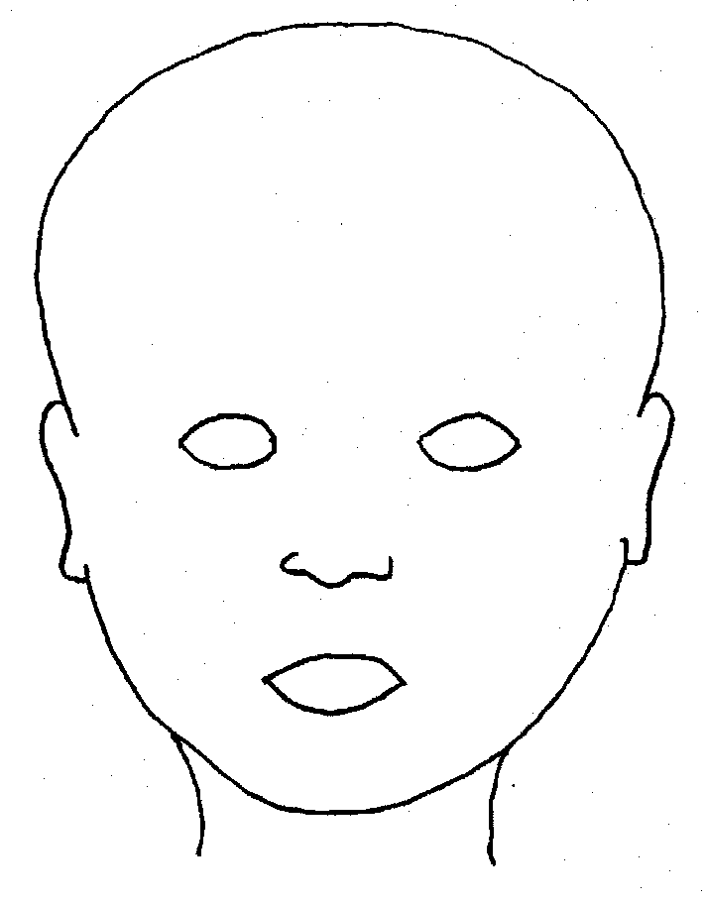
FRONT |  | BACK
 |  | 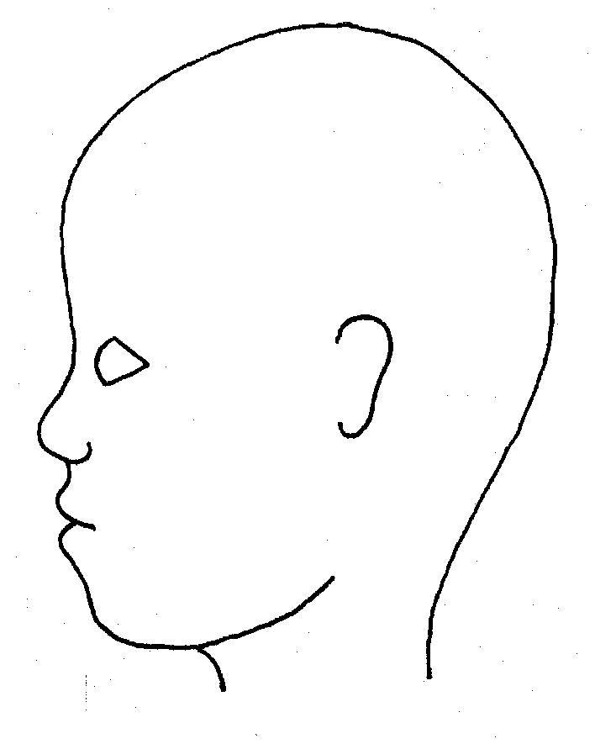
RIGHT |  | LEFT

Name of pupil: |  |  |  |  |  |  | Date and time of observation:
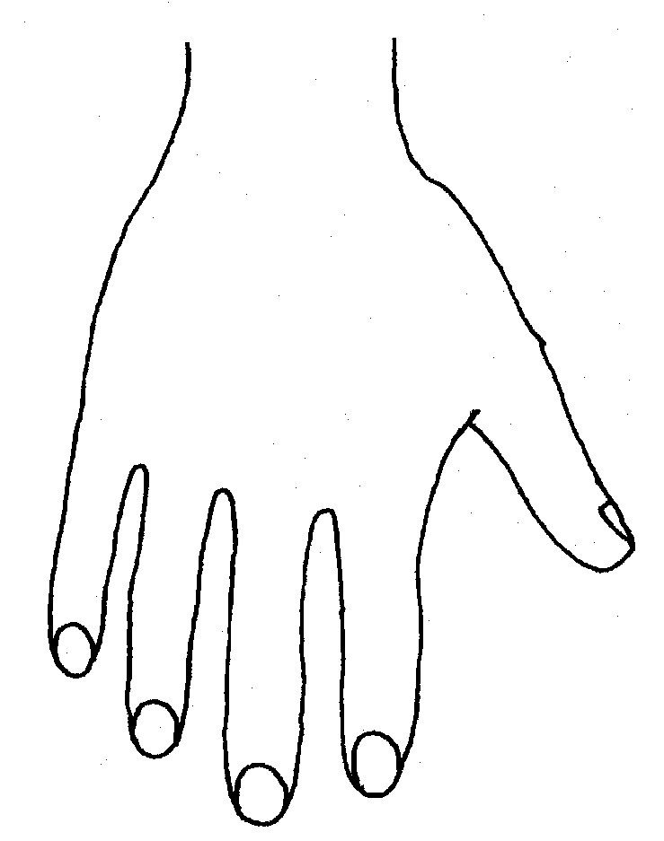 |  |  |  |  |  | 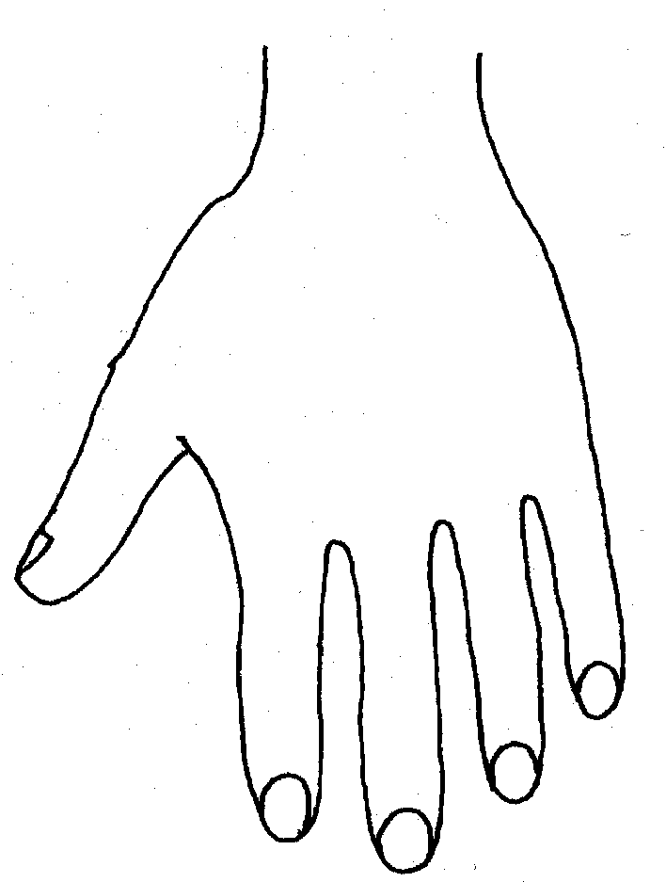
R |  |  |  |  |  | L
BACK
Name of Pupil: |  |  |  |  |  |  | Date and time of observation:
R | TOP |  |  | L | R |  |  | BOTTOM |  |  |  | L
R |  |  |  |  | L
INNER
R |  |  |  |  | L
OUTER
Printed Name, Signature and Job title of staff:

Appendix 5

Dudley’s Thresholds and Early Help
If early help is appropriate, the DSL will generally lead on liaising with other agencies and setting up an inter-agency assessment as appropriate. Staff may be required to support other agencies and professionals in an early help assessment, in some cases acting as the lead practitioner.
The DSL will keep the case under constant review and the school will consider a referral to local authority children’s social care if the situation does not seem to be improving. Timelines of interventions will be monitored and reviewed.
Level 1 - No referral is required. Professionals should contact Dudley’s Family information Service on 01384 814398 to obtain information about support available for children, young people and families.
Level 2 - Partner agencies should complete their own internal assessment as appropriate and forward this to the relevant Family Centre. Alternatively, an Early Help Assessment can be completed and forwarded to the appropriate Family Centre Cluster.
Level 3 - Referrals should be made by completing an Early Help Assessment and forwarding it to the appropriate Family Centre Cluster.
View more information on Dudley Early Help.

Early Help Strategy guidance: http://www.dudley.gov.uk/resident/care-health/children-and-family-care/early-help-for-children-and-families/

https://dudleysafeguarding.org.uk/children/professionals-working-with-children/safeguarding-children-procedures/

.

