THE ROSEWOOD SCHOOL
Staff Responsible Amie Cooper Policy Date – September 2022 Review Date – September 2023

Careers and Social Vocational Policy 2022-2023

Amendment January 2023
The careers provision at Rosewood School is in line with the statutory guidance developed by the Department for Education, which refers to Section 42A and 45A of the Education Act 1997.
As an amendment to the Technical and Further Education Act 2017, the Baker Clause stipulates that schools must allow colleges and training providers access to every student in years 8- 13 to discuss non-academic routes that are available to them.
This states that all schools should provide independent careers guidance from Years 8 -13 and that this guidance should:
• Be impartial
• Include information on a range of pathways, including apprenticeships
• Be adapted to the needs of the pupil in addition, the school is compliant with the careers guidance that the government set out for delivery from 5 January 2018: ‘Careers Guidance and Inspiration for young people in schools.’ This states that all schools must give education and training providers the opportunity to talk to students about approved technical qualifications and apprenticeships. Further information relating to this is set out later in this document, under Provider Access, and have updated our policy to comply with the new legal requirements that came into place on the 1st January 2023.
Please see Careers Advice and Guidance and effective Transition document for further details.
Aims
At Rosewood we aim to ensure that by the end of year 11 all pupils are equipped with the skills to succeed in life. Social skills are of paramount importance and are embedded in our daily routine and curriculum, but they also play a key part in our vocational programmes.
This policy will specify requirements, responsibilities and other guidelines for the planning, organising and the management of school trips, college taster days and work experience placements. This is to ensure that both staff and pupils can have positive experiences whilst minimising health and safety risks.
Purpose
The duty on schools, is to secure independent careers guidance for all year 8-13 pupils, (Rosewood offers placements from year 5 to 11 – careers is implemented into the curriculum from year 5 to inspire and motivate pupils as early as possible. We offer support for all pupils and track placement where we can, alongside Connexions until their 25th Birthday)
Our intention is to offer advice and guidance to our young people so they are inspired and motivated to fulfil their potential. Rosewood aspires to help every pupil develop high aspirations and consider a broad and ambitious range of careers. Inspiring every pupil through more real-life contacts with the world of work can help them understand where different choices can take them in the future.
Rosewood provides face-to-face advice and guidance to build confidence and motivation. This includes consideration of the role that careers professionals can play in supporting pupils as one element of a varied careers programme. All students attending Rosewood School have an Education, Health Care Plan (EHCP). As part of the consultation towards these documents we fulfil the requirement to work with local authorities to identify vulnerable young people, including those with special educational needs and those at risk of not participating post-16, and the services that are available to support them.
Educational visits, College Taster Days and Work Experience Placements are an important feature of the curriculum and allow the pupils to have experiences outside the classroom, which at Rosewood we feel is imperative to improving their social skills and understanding of the wider world.

Work Experience Placements are designed not only to help the pupils achieve more but to build their self-esteem, give them motivation to make positive decisions about their future and help them to develop the key skills they need to be successful.

For any Work Experience or college taster days involving pupils, safety is paramount and for this and other reasons, meticulous planning and organisation are essential.

Work Experience Policy

At Rosewood we believe that work related learning is key to pupils engaging well and making positive steps towards their future, we arrange planned placements that we believe allows the pupil to use the situation of work to develop their knowledge, skills & understanding to help them achieve and learn the key skills for work.

Work Experience is a part of the curriculum that is vital to KS4 pupils experiencing the real world - in order to implement best practice, we have agreed to work in partnership with Dudley EBP (Education Business Partnership) Black Country Consortium, Compass + and Morrisby to provide an excellent integrated work experience programme, where all pupils have the opportunity of 10 days placement with a local approved employer thus increasing their understanding of the working environment encouraging new learning, alongside practising and applying key skills and developing their long- Alternatively, ongoing long term work experience placements can be arranged to allow flexibility to suit the individual needs of the pupil, ensuring that they get the best from the curriculum both vocational and academic alike. Rosewood offers support in identifying and contacting suitable work experience settings for our pupils by providing information about local companies who have agreed to provide placements for pupils and have been risk assessed for Health & Safety suitability and hold the correct insurances.

Aims of our Work Experience Programme

The aim of Rosewood’s work experience programme is to provide all pupils with experience of employment and in turn allow them the opportunity to see themselves effectively operating in an adult working environment.
Work experience helps them to prepare for adult working life through the development of new skills; experiencing new working environments; increasing awareness of the importance of Health and Safety and equal opportunities. The programme is intended to complement and reinforce learning, it gives pupils an opportunity for first-hand experience of employment, to understand employer expectations thereby enhancing their chances of future employability. It also enhances personal and social development; develops greater self-confidence, independence, initiative, responsibility and self-esteem.

Procedures
Consultation with parents
Parents are invited to be involved and contribute towards some aspects of the programme, including suggesting or providing appropriate placements.
Contact and Pre Visit to Employer
An introductory letter or phone call is sent or made from Rosewood to the prospective employer. This includes a brief outline of the pupil, informs them that Rosewood is an ESBD Specialist School and ensures that the prospective employer is both able to and committed to providing an appropriate placement. Pre visits are not always required as most pupils have the confidence to enter a new place of work already knowing who they are being greeted by and the location of the placement, however these can be arranged if necessary.
Arrangements
Arrangements are discussed in depth with the pupil, parents/carers and employers prior to the commencement of any placement. A record is kept of any specific details of placements which is agreed and signed by all parties. These include:
      - Appropriate dress or PPE
      - Travel arrangements to and from the placement
      - Break and lunch times
      - The type of work they will be undertaking during the placement
      - Their roles and responsibilities and what will be required of them
      - Their working hours
      - Health and Safety procedures that need to be carried out
      - Safeguarding / Child Protection

The pupil’s working hours are negotiated in advance of the placement and the employer will receive pupil information such as emergency contacts, and where applicable information of special needs; IEPs; and of health issues.
Commencement of placement
      - Staff accompany pupils to placements if a pre-visit is required and can stay for the first morning to help the pupil with a settling in period.
      - Staff contact the employer throughout the week to provide support to both the pupil and employer and to ensure the placement is successful.
      - Rosewood call placement daily to check attendance

Follow up
Thank you letters are sent out to the employer after the placement has ceased, in order to foster positive working relationships between the school and employers. In turn this allows us to develop a bank of businesses deemed by us to provide the most suitable placements for our cohort of pupils.
Feedback forms to be filled in by pupils to allow us to ensure that placements met their needs and consider further development on an individual basis.
Integration into the Curriculum
In order to provide maximum opportunities for pupils to achieve external accreditation, careers is not allocated as a specific subject on our timetable. However opportunities for Work Related Learning are granted through both PSHE lessons and time with the school’s designated Connexions PA to allow pupils time to complete their curriculum vitae and personal statements, as well as exploring their interests and strengths in order to plan for their future. Where possible, work experience placements complement the pupil’s desired career path, providing them with realistic expectations and an understanding of what is required – ultimately guiding them with decisions about their future.

As part of PSHE, professionals from a range of occupations are invited into school to deliver a short presentation and question and answer sessions on their line of work. Opportunities are provided for pupils to engage with the individuals that then allow the students to broaden their ideas about their desired career path. Work placements provide a valuable context for the delivery of many of the aims and objectives in the PSHE programme. We also use work experience to evaluate the effectiveness of our programme for developing personal and interpersonal skills.
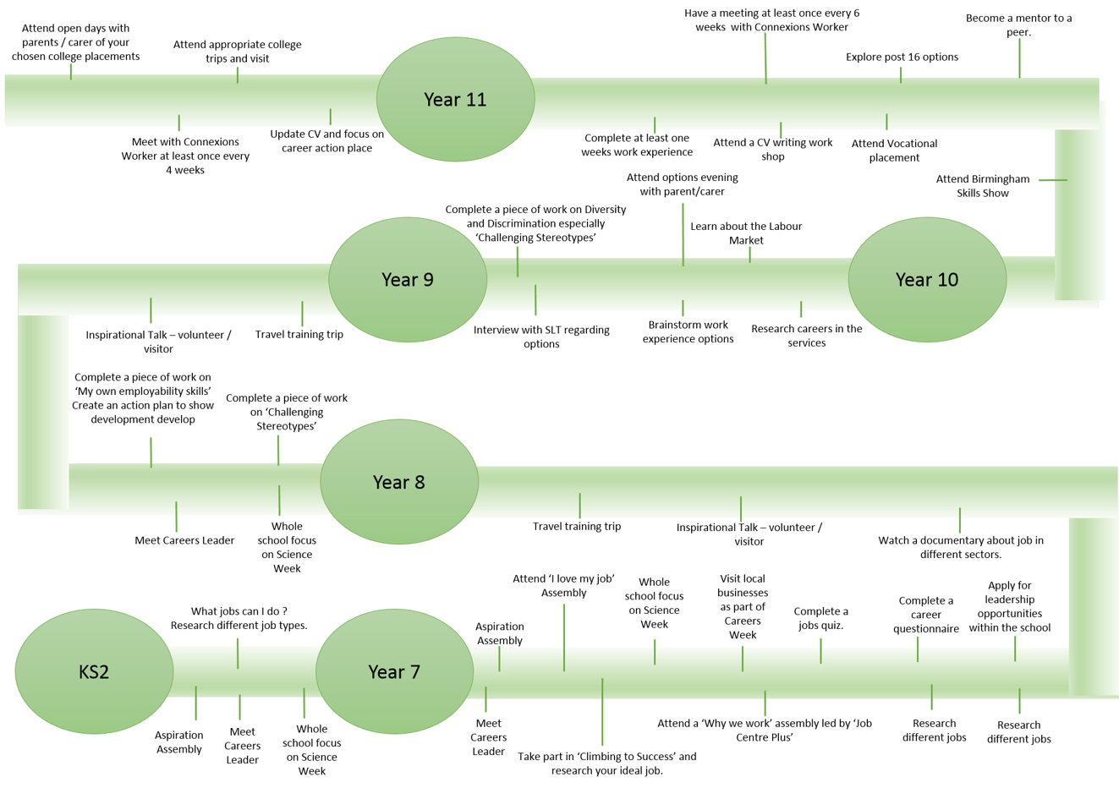
We also ensure that our school meets all of the eight Gatsby Benchmarks for careers by offering the following opportunities

Work experience placements offer many benefits and learning opportunities. In particular employability and key skills, especially communication, working with others and improving self-learning and confidence. It aids their careers education by assisting pupils to understand changes in the world of work better enabling them to plan for their own career choices.

Work Related Learning and in particular Work Experience clearly relate to many aspects of the KS4 National Curriculum. It provides a relevant context for delivering and assessing the whole range of key skills.

In a Vocational Context
Developing work experience as part of the whole curriculum will encourage pupils to view it, not as an opportunity to sample a specific job but rather to try out and test a range of personal and industrial skills. Thus allowing the pupil to highlight was they do not enjoy as much as finding out what they do enjoy. Work experience allows for an elimination process where pupils can find their own niche and prepare for the world of work prior to making the decisions regarding college placements or apprenticeships.

Management Guidelines

Management Issues in Work Experience
There is a member of the Management Team (Amie Cooper) with an oversight of work-related experiences, monitoring quality and supporting those with operational responsibility. Policies and procedures are in place to ensure that pupils are protected from harm, focusing greatest protection on settings in which children may be most at risk. School policies on Child protection, Health and Safety, Equal Opportunity/Race Equality will, of course, be followed with work experience. Work experience coordination is the task of the person or persons responsible for careers education working alongside members of the support staff responsible for college links and work placements. This allows for continuity and effective use of resources.
At Rosewood all teachers play some part in the preparing our pupils for the world of work, however planning and preparation of work experience is over seen by the work experience co-ordinators.
Appropriate time allocation is made to the work experience co-ordinators in order to plan, structure and oversee the effective and safe deployment of the work experience programme. Regular meetings take place to ensure the work experience co-ordinators are all aware of the action plan and any further decisions to maintain a consistent and well organised approach. Minutes are taken from meetings and content from these meetings feed into the action plans at their next review.
Training for school personnel in all aspects of the Work Experience programme comes from Dudley EBP and the Black Country Consortium. Sufficient preparation time is allowed for all participating members of staff to ensure everyone understands the aims of Work Experience, their role and for review and evaluation of the programme to allow for development and future planning.

Work experience and work related learning is covered by the Careers Social and Vocational policy, this is reviewed annually and our planning gives sufficient time to accommodate the required notification period for health and safety checks to be completed.

Section 3 Pupil Entitlement

Rosewood pupils placed in local businesses will be done so in an organisation that has been approved for the purpose of taking pupils on work experience placements (i.e. visited by a competent person and validated for H & S and insurance purposes), ensure that the travel to the work placement has been suitably risk assessed in line with the pupil’s individual needs and abilities, be involved in a structured learning experience, including pre-planning and preparation for work experience, and debriefing afterwards, have access to, backup and support from, a nominated person both in the school and at the company, they will receive sufficient and effective monitoring of the work placement, including a workplace visit by a suitably qualified teacher / school representative (where appropriate) and have the opportunity for debriefing, to review the experience with both school and employer in order to identify learning outcomes.
Special Educational Needs and Work Experience
Consideration is given to the specific needs of each pupil. It is essential to establish the suitability of the individual to the working environment of the placement provider, not only for health, safety and welfare purposes but also their ability to cope with the allotted work-related tasks.
All pupils have an individual risk assessment according to the needs of the pupil, this assessment is discussed and agreed between Work Experience Co-ordinates and whomever has parental guardianship over the pupil.
Pupils at Rosewood have a wide range of abilities and needs, a high percentage of our pupils are registered with CAMHS. Many of our pupils are poorly-motivated as a result of school placements breaking down prior to Rosewood. With this in mind, extra consideration is given to the placement, the preparation and the monitoring. A successful placement is paramount to avoid any damage to the outstanding work we do to improve a pupil’s self-belief and motivation.

Safeguarding
The schools safeguarding and child protection policies are adhered to when allocating placements. Including disability discrimination act, equality act and any changes that are made are adopted.

COVID 19
Although COVID 19 continues to disrupt our career opportunities we strive to deliver as many workshops as possible, invite guest speakers, visit the world of work and encourage work experience placements.
We are currently working with Black Country Consortium to develop the opportunities offered to our pupils, and have developed a bank of online resources.

