THE ROSEWOOD SCHOOL
Staff Responsible Mrs G. Hand Policy Date – September 2022 Review Date – September 2023

SEND POLICY AND INFORMATION REPORT 2022-2023

THE ROSEWOOD SCHOOL

SEND POLICY AND INFORMATION REPORT 2022-2023

Member of staff responsible - Mrs G Hand
Mr D Kirk

Date of Policy - September 2022

Review Date - September 2023

Ethos
Rosewood School is an urban special school for boys of secondary age who primarily have Social, Emotional and Mental Health difficulties. Pupils are drawn from all over the borough and reflect a wide social mix and very varied family backgrounds.
As a school, we are committed to offering an inclusive curriculum to ensure the best possible outcomes for all our pupils irrespective of their needs and abilities.
At Rosewood, we provide small group teaching with an emphasis on socialisation skills designed to help each pupil make progress. We aim to add value to all our pupils no matter what their learning difficulty. Our school thrives on effective relationships based on mutual respect, and our prime aim is to offer our pupils the chance of success through education. We hope that by building trust and offering a curriculum rich in experiences, alongside emotional support and stability, our pupils have a strong chance of achieving their potential and making a success of their future.
The school believes that all pupils with a Special Educational Needs (SEN) must have their needs recognised and assessed, with appropriate and timely intervention put in place. All staff have due regard to general duties to promote disability equality. The school strives to deliver appropriate curriculum to:
- Provide suitable learning challenges
- Meet the pupils’ diverse learning needs
- Remove the barriers to assessment and learning

Aims
Our SEN policy and information report aims to:
- Set out how our school will support and make provision for pupils with Special Educational Needs (SEN).
- Explain the roles and responsibilities of everyone involved in providing for pupils with SEN.

Legislation and Guidance
The new SEND Code of Practice (Department for Education and Department of Health, 2014), states that all children and young people are entitled to an education that enables them to make progress so that they:
- Achieve their best
- Become confident individuals living fulfilling lives
- Make a successful transition into adulthood, whether into employment, further or higher education or training
This policy and information report is based on the statutory Special Educational Needs and Disability (SEND) Code of Practice (2014) and the following legislation:
- Part 3 of the Children and Families Act 2014, which sets out schools’ responsibilities for pupils with SEN and disabilities.
- The Special Educational Needs and Disability Regulations 2014, which set out schools’ responsibilities for Education and Health Care plans (EHCPs), SEN co-ordinators (SENCOs) and the SEN information report.
The SEND Code of Practice can be found on Government website (www.gov.uk).

Definitions
A pupil has SEN if they have a learning difficulty or disability which calls for special educational provision to be made for them.
They have a learning difficulty or disability if they have:
- ‘A significantly greater difficulty in learning than the majority of others of the same age’
or
- ‘A disability which prevents or hinders them from making use of facilities of a kind generally provided for others of the same age in mainstream schools’.
Special educational provision is an educational or training provision that is additional to, or different from, that made generally for other children or young people of the same age by mainstream schools.

Roles and Responsibilities
The SENCO at Rosewood is Mrs Georgina Hand and the Access to Learning Manager is Mrs Karen Phipps.
The SENCo will:
- Oversee the day to day operation of the SEND policy and update annually.
- Work alongside all staff to assist them in identifying, assessing and planning for students’ needs and ensuring that all students make progress.
- Contributing to and, where necessary, leading the Continuing Professional Development (CPD) of staff.
- Assess all pupils reading and spelling ages and plan interventions accordingly.
- Co-ordinate and monitor interventions and the range of support available to pupils at Rosewood following the ‘Assess, Plan, Do, Review*’ cycle.
- Deploy Teaching Assistants.
- Provide resources to help and enhance learning, where needed.
- Liaise with external agencies and be the point of contact for them, especially the local authority and its support services.
- Liaise with parents/carers to inform them of the ongoing support provided for their child.
- Monitor, evaluate and report on the provision for students with SEND to the Governing Body in conjunction with the Senior Leadership Team and Headteacher.
- Refer to and update ‘All About Me’, SEN Support Pyramid** and Staff Responsibilities documents as and when needed.
The Access to Learning Manager will:
- Work with the SENCo and other staff to identify and meet specific learning needs of pupils.
- Help to baseline test all new pupils.
- Work with the SENCo to assess all pupils’ reading and spelling ages.
- Carry out group interventions to support English (including spelling), Maths and Science.
- Individualise learning programmes for pupils.
- Ensure each pupil has a ‘Learning Journey’ which all staff can refer to.
- Organise and monitor the whole school reading scheme, ‘ERIC’.
- Refer to ‘All About Me’ and SEN Support Pyramid documents as and when needed.
- Support the SENCO in her duties.
The SEN Governor will:
- Help to raise awareness of SEN issues at governing board meetings.
- Monitor the quality and effectiveness of SEN and disability provision within the school and update the governing board on this.
- Work with the Headteacher and SENCO to determine the strategic development of the SEN policy and provision in the school.
The Headteacher will:
- Work with the SENCO and SEN Governor to determine the strategic development of the SEN policy and provision in the school.
- Have overall responsibility for the provision and progress of learners with SEN and/or a disability.
Class Teachers
All staff have a responsibility for ensuring that they have the appropriate knowledge, skills and attitudes to meet the needs of all children and young people with SEN. The SEND Code of Practice (2001) states that, ‘All teachers are teachers of children with special educational needs’ and the SEND Code of Practice (2014) says that ‘class and subject teachers, supported by the senior leadership team, should make regular assessments of progress for all pupils’. Where concerns are identified, teachers should work with the special educational needs co-ordinator (SENCO) to assess and identify the best provision possible.

Each class teacher will:
- Ensure they follow this SEN policy.
- Monitor the progress and development of every pupil in their class.
- Work closely with any teaching assistants or specialist staff to plan and assess the impact of support and interventions and how they can be linked to classroom teaching.
- Refer to ‘All About Me’ and SEN Support Pyramid documents as and when needed.
- Work with the SENCO to review each pupil’s progress and development, raise any concerns and decide on any changes to provision.
- Implement the school’s behaviour policy.
*
The Support Pyramid shows the graduated approach to different levels of support the pupils receive at Rosewood.
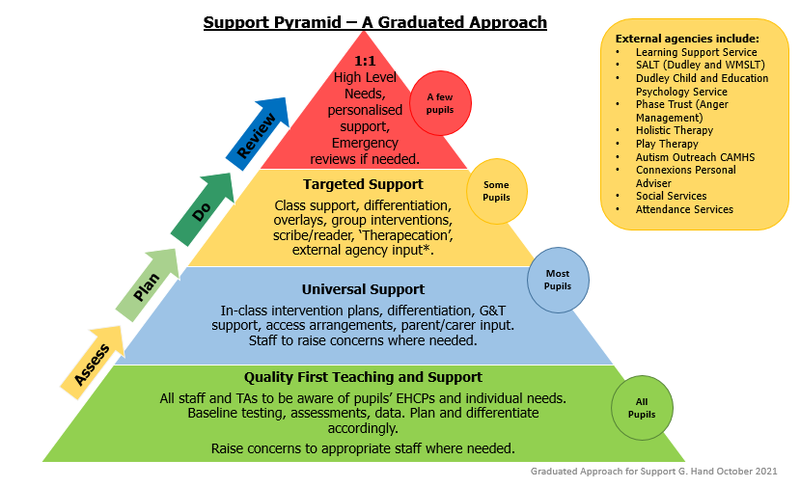
**
Admissions
Rosewood school caters for up to 58 pupils, from the age of 10-16 and stated as having Social Emotional and Mental Healthy difficulties. In addition to this, they may have other needs such as; Dyslexia, Dyspraxia, Attention Deficit Hyperactivity Disorder (ADHD), Autistic Spectrum Disorder (ASD) or Moderate Learning Difficulties.
All pupils must have a Statement of Special Need and are referred to us by their Local Authority. Parents/ carers and prospective pupils are then invited to view the school and will have the opportunity to meet staff and pupils. Following this initial visit the school will assess the pupil and will make an offer of a place via the Local Authority. A date will be arranged to complete risk assessments and other associated paper work.

Statement of SEN (EHCP) and Annual Reviews
All pupils attending Rosewood have been placed there by their local and have a statement of Special Educational Needs / EHCP which details their needs and provision.
Every year, a meeting will be held for to review the Educational Health Care Plan for each pupil. A date will be set at the beginning of the year for each year group and the parents/carers and all professionals involving the pupil, including the LA, will be invited to attend the meeting at least two weeks before the review date.
The Annual Review report will give detailed information on academic progress as well as any other specific need.

Accessibility
Rosewood School relocated to a newly refurbished site in Coseley in 2008. The school is on one level, all doors and corridors are wide and wheel chair accessible. There are two reserved disabled spaces in the car park. There is a disabled toilet and shower facility. All external doors are accessible through electronic key fob and the outdoor area including playground and school field are fully accessible. We also have a high staff pupil ratio to support pupils and keep all pupils and staff safe.

Curriculum and Interventions
Rosewood School provides for children with a range of specific needs from 10 to 16 years. All Rosewood children access a mainstream National Curriculum within small teaching groups. Our school has a strong commitment to academic accreditation as well as meeting pupils’ personal needs. We believe that whatever a child’s previous history or disability may have been - success through education is the one true vehicle to improving the chances of a happier life and socio-economic success.
At Rosewood, we listen to our pupils’ opinions and needs to create learning pathways that are appropriate to their abilities and will help them achieve their aspirations. The curriculum comprises of the following subjects;
- English
- Mathematics
- Science
- Food Technology
- Physical Education
- Art
- Drama
- Computing
- History
- Geography
- Personal Social Health Education
- Religious Education
- Modern Foreign Languages
- Design Technology

All teachers are responsible and accountable for the progress and development of all the pupils in their class. High quality teaching is our first step in responding to pupils who have SEN. This will be differentiated for individual pupils.

We make the following adaptations to ensure all pupils’ needs are met:
- Ensuring quality first teaching
- Differentiating our curriculum to ensure all pupils are able to access it, for example, by grouping, 1:1 work, teaching style, content of the lesson, etc.
- Adapting our resources and staffing.
- Using recommended aids, such as laptops, coloured overlays, visual timetables, larger font, etc.
- Differentiating our teaching, for example, giving longer processing times, pre-teaching of key vocabulary, reading instructions aloud, etc.

We will also provide the following interventions:
- 1:1 Daily Reading
- Group Interventions for English, Spelling, Maths and Science
- Refresher sessions for Phonics
- LAC interventions
- PASS (Pupils’ attitudes to self and school)
- Counselling
- Educational Psychologist follow up work
- Holistic Therapy including Seated Massage Therapy, Aromatherapy, Meditation, Mindfulness, Reiki and Reflexology
- Music
- Anger Management (Phase Trust)
- Animal Therapy
- Play Therapy

Staffing
At Rosewood, we have a high staff pupil ratio. Students are taught in small class groups, no more than eight, with experienced teachers and Higher Level Teaching Assistants able to give one-to-one help where it is needed. The teaching staff tailor the pupils’ curriculum to their individual needs.
The Access to Learning Manager will also provide intervention groups, within lessons, for those pupils with specific learning needs.
Through the monitoring and evaluating of our provision, the SENCO, along with the Senior Leadership Team and Headteacher, will identify any particular professional development needs of the staff. This will, where appropriate, be linked closely to the school’s Development Plan and/or teachers’ appraisal objectives.

Outside Agencies
Close links are maintained with the LA, Health Authority and other services in order to ensure that the school makes appropriate provision for pupils with Special Educational Needs.
These services include:
- Dudley Learning School Service (DLSS)
- Dudley Child and Education Psychology Service
- Phase Trust (Anger Management)
- Holistic Therapy
- Physical and Medical Inclusion Service
- Sensory Support Services (Hearing Impaired & Visual Impaired)
- Autism Outreach Service
- CAMHS
- Speech and Language Therapy (Dudley Service and West Midlands SALT)
- Dyslexia West Midlands
- Occupational Therapy
- School Nurse
- School Dentist
- School Health eh
- Independent Travel

Parents and Carers
Our school actively encourages parents and carers to engage in their child’s education. Furthermore, because of the nature of need our pupils present, it is vital that information is shared quickly and effectively. This helps promote a close relationship between home and school as well as enabling our staff to deal with children’s specific needs without delay. Parents will have the opportunity to meet with staff three times a year in a formal setting including a parents’ evening which is usually held at the end of the summer term. Parents and carers are also invited and encouraged to attend other meetings surrounding their child such as Annual Reviews and PEPs (Personal Education Plan).

Monitoring and Evaluating
It is extremely important to us that each pupil is receiving the correct provision to support their individual needs in order to make the best possible progress. We therefore ensure we evaluate the effectiveness of provision for pupils with SEN by:
- Reviewing pupils’ individual progress towards their goals each term
- Reviewing the impact of interventions after each half term
- Using pupil questionnaires
- Monitoring by the SENCO
- Holding annual reviews for pupils with statements of SEN or EHC plans
- Good communication between school and parents and carers

Complaints Procedure
If parents/carers have a complaint concerning provision for their child, they should discuss this with the SENCo. If this proves unsuccessful the matter should be referred to Senior Leadership Team or Headteacher. Should the matter still be unresolved, the parents/carers should contact the SEN Link Governor. If the complaint remains unresolved the Chair of Governors should be involved and finally the complaint should be taken to the Local Authority.

This policy will be reviewed in September 2023.

