Careers Advice Guidance and Effective Transition

Provision
Careers at Rosewood School is the responsibility of Mrs A. Cooper and Mr L. Wilkes under the direction of Mr D. Kirk. Careers Education is taught cross curricular but is strongly supported by Miss J. Crowther PSHE Lead. Contact details: acooper@rosewood.dudley.sch.uk Lwilkes@rosewood.dudley.sch.uk jcrowther@rosewood.dudley.sch.uk
The duty on schools, is to secure independent careers guidance for all year 8-13 pupils, (Rosewood offers placements from year 5 to 11 – careers is implemented into the curriculum from year 5 to inspire and motivate pupils as early as possible. We offer support for all pupils and track placement where we can, until their 21st birthday)
Our intention is to give advice and guidance to our young people so they are inspired and motivated to fulfil their potential. Rosewood aspires to help every pupil develop high aspirations and consider a broad and ambitious range of careers. Inspiring every pupil through real-life contacts with the world of work can help them understand the different choices they can take and how this can shape their future.
Rosewood provides face-to-face advice and guidance to build confidence and motivation. This includes consideration of the role that careers professionals can play in supporting pupils as one element of a varied careers programme. All students attending Rosewood School have an Education, Health Care Plan (EHCP). As part of the consultation towards these documents we fulfil the requirement to work with local authorities to identify vulnerable young people, including those with special educational needs and those at risk of not participating post-16, and the services that are available to support them.

Introduction
Rosewood School offers a relevant and engaging careers curriculum which meets the differing needs and requirements of our pupils. This is developed throughout a pupil’s time at the school and is always supportive of their abilities, strengths and skills.
Aims and purpose
• Prepare pupils for the transition to life after Rosewood
• Support pupils in making informed decisions which are appropriate for them
• Provide pupils with well-rounded experiences
• Develop personal characteristics such as social skills, communication, independence and resilience
• Inspire and motivate pupils to develop themselves as individuals

This document summarises the statutory guidance and recommendations.
It then outlines the provision of careers education, work experience and provider access.
Statutory requirements and recommendations.
The careers provision at Rosewood School is in line with the statutory guidance developed by the Department for Education, which refers to Section 42A and 45A of the Education Act 1997.
This states that all schools should provide independent careers guidance from Years 8 -13 and that this guidance should:
• Be impartial
• Include information on a range of pathways, including apprenticeships
• Be adapted to the needs of the pupil in addition, the school is compliant with the careers guidance that the government set out for delivery from 5 January 2018: ‘Careers Guidance and Inspiration for young people in schools.’ This states that all schools must give education and training providers the opportunity to talk to students about approved technical qualifications and apprenticeships. Further information relating to this is set out later in this document, under Provider Access.
Careers Provision at Rosewood
All pupils have access to the following:
• Rosewood Provision – refer to further provision documentation
• Visitors in to school and offsite visits support pupils in developing their understanding of a range of different post 16 pathways.
• All pupils from Year 9 have access to advice and guidance from our connexions advisor
• Pupils have access, through school arranged or facilitated events, to relevant careers events hosted in various locations
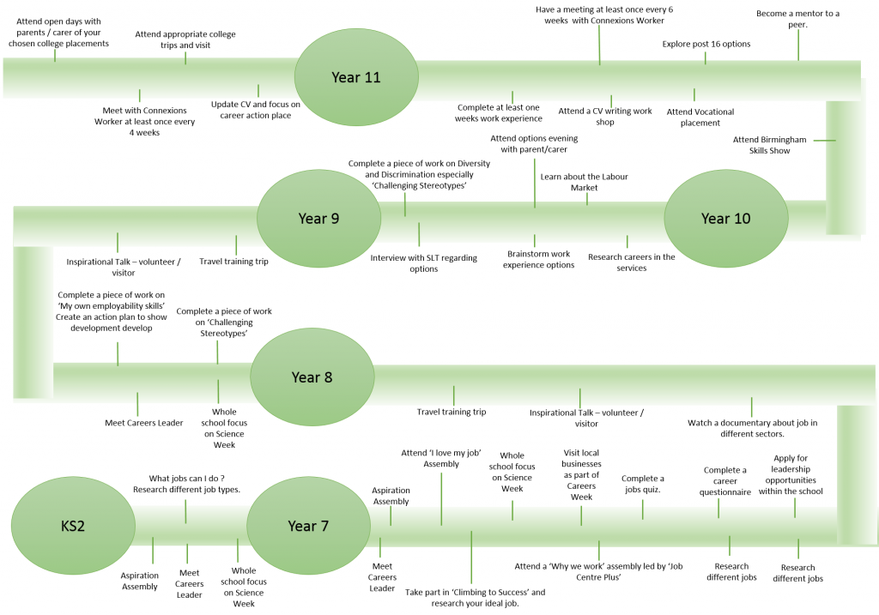

All pupils have their own ‘career pathway’ folder to evidence how we have met the above career pathway plan, and track their outcomes.

Providers Access Policy Statement
This policy statement sets out the school’s arrangements for managing the access of providers to pupils at the school for the purpose of giving them information about the provider’s education or training offer. This complies with the school’s legal obligations under Section 42B of the Education Act 1997.
Pupil entitlement
All pupils in years 8-11 are entitled:
•To find out about technical education qualifications and apprenticeships opportunities, as part of a careers programme which provides information on the full range of education and training options available at each transition point;
• To hear from a range of local providers about the opportunities they offer, including technical education and apprenticeships – through options events, assemblies and group discussions and taster events;
• To understand how to make applications for the full range of academic and technical courses.

Management of provider access requests procedure
A provider wishing to request access should contact A Cooper, Telephone: 01384 816800; Email: acooper@rosewood.dudley.sch.uk.
Opportunities for access
A number of events, integrated into the school careers programme, will offer providers an opportunity to come into school to speak to pupils and/or their parents/carers.
Premises and facilities
The school will make the main hall, classrooms or meeting spaces available for discussions between the provider and students, as appropriate to the activity. The school will also make available equipment to support provider presentations. This will all be discussed and agreed in advance of the visit with the Careers Leader or a member of their team. Providers are welcome to leave a copy of their prospectus or other relevant course literature with us. This will be made available to pupils and families as appropriate.
Connexions
The governing body must ensure that the independent careers guidance provided:
• Is presented in an impartial manner
• Includes information on the range of education or training options, including apprenticeships and other vocational pathways
• Will promote the best interests of the pupils to whom it is given.
At Rosewood School Impartial Careers Advice and Guidance is provided by Connexions. This is through targeted support. The school is allocated a named Personal Assistant. (Nathan Hutchinson is our named PA) This PA fulfils the role in several ways:
- Attending annual reviews from Y8 onwards
- Working with school and families to agree short term priorities for employment, community inclusion, and independent living and health pathways. If other support agencies are involved, their input is included. This is documented in the EHCP
- Working with school and families to determine long term outcomes for adult life in the areas of employment, community inclusion, and independent living and health pathways. These are documented in the EHCP.
- Visiting families to build relationships and understanding of individual student need
- Visiting school to observe students and gain understanding of needs, abilities and aspirations
- Supporting school staff to develop an understanding of local options for our student population
- Supporting students to access the connexions website
- Supporting families to visit a range of educational options which may be available after school
- Supporting families to apply for post school options.
It is required to provide information to students about the financial support that may be available to help them stay in education post-16. At Rosewood, this is through the provision of an EHCP.

Transition
We aim to equip all of our pupils so that college is a possible next step, college is likely to be successful if the right support is secured and everyone involved has a clear understanding of the student’s needs.
It may also be a part of a package of support, surrounding the student which may include social and emotional support. We take our responsibility to prepare our students for the next stage of their adult life very seriously, and as such, have a team of staff to support this, and a whole school approach to careers. In addition to this, our LAC lead (Mrs L. Stallard) and our DSL (Mrs B. Guider) work closely with the transition social care team, initially through annual reviews of EHCP to ensure our students’ needs are fully understood and appropriate provision can be planned.
During the last year at Rosewood, the school team organise and facilitate transition meetings with all agencies involved with our students. Central to this process are our students and families. The wider group may include: connexions, social care, health professionals, private providers, voluntary sector, therapists, and or others. We support our families to investigate available opportunities and decide preferences. Throughout all of this, the students are involved in as meaningful a way as possible, attending meetings if appropriate and visiting options for future placements. Once a decision has been reached we support our students and future placements with transition. This can be over the course of the year, or as long or short as is deemed appropriate. It will also take various formats as transition is planned and delivered on an individual basis.

Rosewood Study Programme
In preparing our students for the next stage of their adult life we include the following, in accordance with the Careers guidance and inspiration in schools (DfE March 2015).
We also take account of the Gatsby Benchmark Standards, details of which are included at the end of this information.
• Providing access to a range of activities that inspire young people, including employer talks, careers fairs, motivational speakers, colleges, coaches and mentors.
• Building strong links with employers who can help to boost young people’s attitudes and employability skills, inform pupils about the range of roles and opportunities available and help them understand how to make this a reality.
• Offering high quality work experience that properly reflects individuals’ interests and strengths, and supports the academic curriculum. All students have personal pathways meetings with our Connexions worker and Mrs A Cooper during which they discuss their targets in relation to key skills, vocational and work experience pathways.
• Widening access to advice on options available post-16, for example, apprenticeships, entrepreneurialism or other vocational routes. This should also include giving other post-16 providers opportunities to engage with pupils on school premises. This is delivered as relevant to our student population, working with local colleges and other providers, usually on an individual student level.
• Consciously working to prevent all forms of stereotyping in the advice and guidance they provide, to ensure that pupils from all backgrounds and diversity groups consider the widest possible range of careers, including those that are often portrayed as primarily for one or other of the sexes.
• Creating a learning environment which allows and encourages pupils to tackle real life challenges which require them to manage risk and to develop their decision making, team building and problem solving skills. Having high expectations of all pupils. Facilitating access to a range of inspirational role models can instil resilience, goal setting, hard work and social confidence in pupils, encouraging them to overcome barriers to success.
- All students at Rosewood have individual targets and are supported by a wide range of staff to work towards aspirational yet realistic future options
- Having a clear focus on the enterprise skills, experience and qualifications that employers want can support preparation for work and help students gain confidence.
- Rosewood’s overall strategy for advice and guidance recognises that our students will need additional support before they are ready to make decisions about their next steps.
Impact and Effectiveness
At Rosewood, due to the effective transition planning process, students do move on to future options.
These include:
• Local colleges
• Independent Specialist Providers
- Apprenticeships
- Work Placements (Voluntary and Paid)
Generally, a ‘package’ of support, including one or more of the above is achieved. There is a lack of suitable provision for our young people leaving us. Rosewood works pro-actively to secure the best available solutions for our families.
Leavers Destinations
2020 - 2021 – 13 Leavers – 100% EET
1 – Apprenticeship
2 – Work placement
10 – Local college’s with EHCP
2019 - 2020 - 5 Leavers – 80% EET
3 – Local College (2 with EHCP)
1 – College out of borough
1 – (Unable to disclose – Safeguarding)
2018 - 2019 – 4 Leavers – 100% EET
4 – Local College with EHCP
2017 - 2018 – 6 Leavers – 100% EET
6 – Local college’s with EHCP
Study Programmes
Teaching and learning is driven at Rosewood School through an ambitious curriculum. It has been designed with the aim of developing the knowledge, skills and abilities of pupils allowing increasing fluency and independent application of what they know and can do. The curriculum delivers a creative and practical approach to teaching and learning that challenges the more able further in their learning and appropriately supports children who find aspects of their learning more difficult. This enables success to be experienced by all. Our ultimate aim is to offer pupils the opportunity to achieve the outcomes and qualifications they need to progress into their chosen career pathways and to equip them for life after Rosewood.
In Key Stage 4 our curriculum tapers to allow pupils to focus their talents on subjects where they can attain recognised qualifications in the core subjects of English, Maths, Biology, Geography, ICT and two further subjects of their choice. Pupils leave Rosewood with between 8 and 10 GCSEs or equivalent.
Further to our academic curriculum, we provide pupils with careers guidance and support throughout PSHE curriculum and various enrichment activities. From year 9, pupils have access to college courses (current providers include Black Country Wheels and Work & Learn), and we aim to offer at least 10 days of work experience to all pupils before the end of year 11. This enables pupils to ensure they are making the correct choices about their futures and maximises their opportunities to succeed.

Students are encouraged to take part in other meaningful non-qualification activities. Such activities should again be planned and organised by the provider, and may include enrichment activities to build character (as recognised by the DfE character awards), tutorials, study skills, leadership, team-work or self-management skills and activities such volunteering, supporting the local area with food bank or focusing on their ArtsMark award. Opportunities for students arranged to meet individual needs and meet the chosen pathway of the student. They may include work related learning within school, on either site, independent travel training, community access opportunities or supported work related learning offsite; at social business partnerships or with voluntary organisations.
At Rosewood we ensure all study programmes reflect the student’s longer term aims and aspirations, and support them to achieve their goals. In accordance with expectations, all students nearing their planned leaving date are encouraged and supported to apply for local college placements or apprenticeships.

The 8 Gatsby Benchmarks are:
- A stable careers programme ​
- Learning from careers and labour market information ​
- Addressing the needs of each student
- Linking curriculum learning to careers
- Encounters with employers and employees
- Experiences of workplaces
- Encounters with further and higher education
How Rosewood Meet those Benchmarks

