THE ROSEWOOD SCHOOL
Staff Responsible Mrs G. Hand Policy Date – September 2021 Review Date – September 2022

READING AND PHONICS POLICY 2021-2022
Rosewood Reading and Phonics Policy 2021-2022

Member of staff responsible - Mrs G Hand
Mr D Kirk
Mr B Whittall

Date of Policy - September 2021

Review Date - September 2022

Intent:
- To develop a love of books and reading.
- To develop reading strategies and skills: fluency, accuracy, understanding and response to different texts.
- To read and enjoy a variety of texts (e.g. stories, poems, rhymes, non-fiction) from a variety of sources: library, class book corners, ICT.
- To create a strong, embedded reading culture through a rich language environment within classrooms and the wider school environment.
- To deliver a structured and consistent whole school approach to reading.
- To recognise the value of parents/ carers as essential components in supporting and developing children’s reading skills and love of reading.
- To rigorously monitor and assess children’s progress in reading and identify those who require extra support and intervene at an early stage.
- To embed a whole school approach to the teaching of reading.

Inclusion Statement
At Rosewood School, we guarantee that every child is given the opportunity to be included in all aspects of school life and in all areas of the curriculum. We are determined that every pupil will have the opportunity to learn to read, regardless of their background, needs or abilities. As a school, we strive to ensure that as many of our pupils are at, or exceed, ‘ARE’ (age related expectation).

Implementation:
Planning/Teaching
Teaching and learning in the school ensures that all children are set suitable learning challenges. A broad range of teaching styles are adopted in response to the learning needs of individuals. We make every effort to overcome potential barriers to learning for individuals and for groups of children.
Reading in Key Stage 2
The ultimate aim in KS2 is for all pupils to develop their reading at a significant rate to reduce deficit between their reading age and their chronological age, and to build a love of reading and books.
Most pupils who attend Rosewood KS2, arrive with a poor understanding of phonics and the skills required to fully develop as a fluent reader. As such, pupils are reluctant readers. The aim of KS2 is to develop pupils’ phonetic knowledge through targeted phonics lessons to provide all pupils with the basic skills of word recognition and reading. These skills are taught using a systematic phonics programme, Read, Write, Inc. Fresh Start. The programme is specifically designed for pupils that have progressed through their earlier primary school years, without acquiring and retaining the skills to read and it is carefully levelled to get pupils ready to read.
Additionally, pupils are encouraged to read every day, being heard by a member of staff, who logs what the pupil has read, making comments on what the pupil has done well and areas for improvement. The pupils read texts that have been carefully selected for them from a banded reading scheme (Rising Stars-Reading Planet) based on their reading age. These texts include comprehension questions which staff ask the pupils to develop their understanding of the text. Pupils also have access to their reading book at home using an online login. This online login includes questions to check the pupils’ understanding. All KS2 pupils now have a reading record (allocated by reading age*) that they should take home with a Rising Stars reading book for parents/carers to fill in and send back to school.
There is clear communication and collaboration throughout the Key Stages to ensure different texts are covered as class readers.

Reading in Key Stage 3 and 4
Pupils will be taught to develop an appreciation and love of reading, and read increasingly challenging material independently through:
- Reading, as a class, and discussing a wide range of fiction and non-fiction, including in particular whole books, short stories, multi-cultural literature, poems and plays with a wide coverage of genres, historical periods, forms and authors
The range will include high-quality works from:
- English literature, both pre-1914 and contemporary, including prose, poetry and drama
- Shakespeare (as part of an Introduction to his life and works).
- Some world literature
- Choosing and reading books independently for challenge, interest and enjoyment
- Re-reading books encountered earlier to increase familiarity with them and provide a basis for making comparisons

Account will be taken of the reading ages of students and of classes so that all abilities can access, and enjoy, this reading in some form.
Reading Material
We have a wide range of fiction and non-fiction texts in our library that all pupils can easily access. Class readers are from a range of different authors from different backgrounds, ethnicities and religions. The reading schemes used are predominantly ‘Rising Stars’ and ‘Rapid Plus’ which are organised using a book band system. Books from different schemes are organised so that those at a similar level are grouped together. This means that children can access a wide variety of books on different subjects and develop fluency using a range of texts.
ERIC (Everyone Reads in Class)
As the title suggests, the main emphasis of an ERIC session is reading. Although we need to encourage pupils to read for pleasure, we also need to endeavour to improve spelling, comprehension and general knowledge skills. It is with this in mind, that the ERIC session as we know them today came about.
There are three components to the ERIC sessions – spelling challenges, reading/comprehension/general knowledge challenges and reading from a text. The eight spelling challenges are words taken from the top primary school suggested spelling list, and once all eight have been completed, most of our pupils should be competent at spelling. The ten reading challenges have ten levels per category and are designed not only to improve reading and comprehension, but also the pupil’s general knowledge. In addition to this, we have now introduced a book challenge. Each pupil can read and answer comprehension questions 4 chosen books. For each challenge they complete, they will receive 25 extra reward points.
An ERIC session is divided into three distinct parts:
· 10 minutes working on the appropriate spelling challenge.
· 10 minutes working on the appropriate reading challenge.
· The remainder of the session is for reading (texts will be provided).
The pupils have now been grouped together with those of a similar reading age. There are also Gifted and Talented pupils who will be a part of a ‘book club’ and will read and discuss appropriate texts.
Reading for Pleasure
There are many opportunities at Rosewood for pupils to read for pleasure. The pupils can have access to the books and texts in the library at break, lunch and tutor times, which they are allowed to take home, on request.
Reading Club takes place on Tuesday and Thursdays at break and lunch times for pupils who would like to sit and read quietly. This can be with personal books they choose to bring in, or books from the library. These pupils also have the opportunity to be heard read, if they wish to do so. A record will be kept of who attends each session.
Phonics
Phonics is a key skill that supports the development of early reading skills and our mission is to teach every child to read and write and to keep them reading. All KS2 pupils, and some KS3 pupils, where necessary, are phonics screened and assessed. Those pupils who need Phonics interventions use the Read Write Inc. (RWI) Fresh Start programme. This aims to:
• Develop each child so that they are able to read with fluency and good understanding
• Develop a love of reading that will stay with children all their lives
• Write clearly, accurately and coherently, adapting their language and style in and for a range of contexts, purposes and audiences Implementation
At Rosewood, we follow the structure of RWI. Our children are provided with a variety of opportunities to develop and extend their phonics skills across Key Stage 2.
Where necessary, phonics will be taught as a discrete lesson four times a week and will include phonics as part of teaching and learning throughout other curriculum lessons on a daily basis. It will also be continued into Key Stage 3 to support those children who do not yet have the phonic knowledge and skills they need. Children are grouped according to their phonic knowledge into smaller group sizes.
Assessments/Rewards
All pupils are assessed at the beginning of the year and we are then able to work out which pupils are below ‘ARE’ and need interventions and differentiation within class and which pupils need specific interventions and further support. We will constantly apply the ‘Assess, Plan, Do, Review Cycle’ to review what pupils are receiving which interventions and will monitor the impact of them.
Those who are ‘ARE’ or above the age of 12 are only assessed once a year. Those who are below ‘ARE’ are tested termly and is constantly reviewed. Pupils who make significant progress in Reading and Spelling are rewarded with curriculum merits, phone calls to parents/ carers and the opportunity for a visit to Waterstones visit.
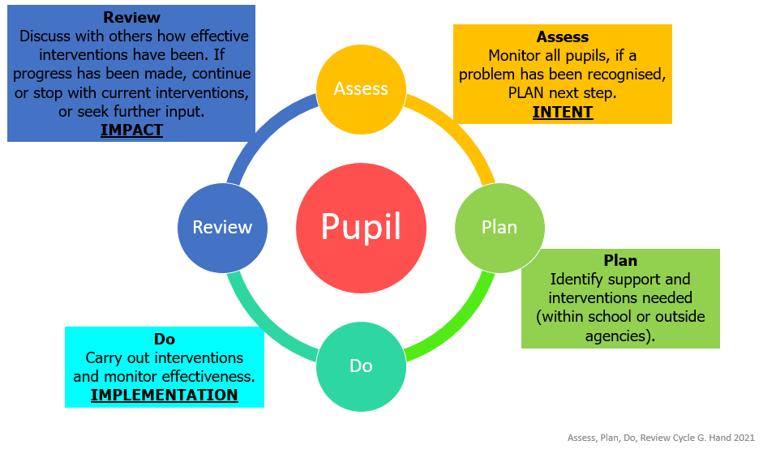
The Waterstones visit is where the Headteacher and SENCo take a small number of pupils out for lunch and to Waterstones in Birmingham where they are able to choose a book(s) to take home.
Reading Interventions
The SEN team, in collaboration with the class teachers, identify pupils that are not making adequate progress in reading and enrols these pupils into an appropriate reading intervention.
There are a variety of reading interventions that we provide in school.
- In class support and differentiation
- 1:1 Daily Reading - all pupils are given the opportunity to be heard read out loud and discuss the text – there are two folders for KS2 and KS3/4 where this information is recorded
- Group Reading interventions using the Rapid Plus Programme
- Group Interventions for Phonics using Read Write Inc. Fresh Start
- 1:1 LAC interventions, which includes reading activities
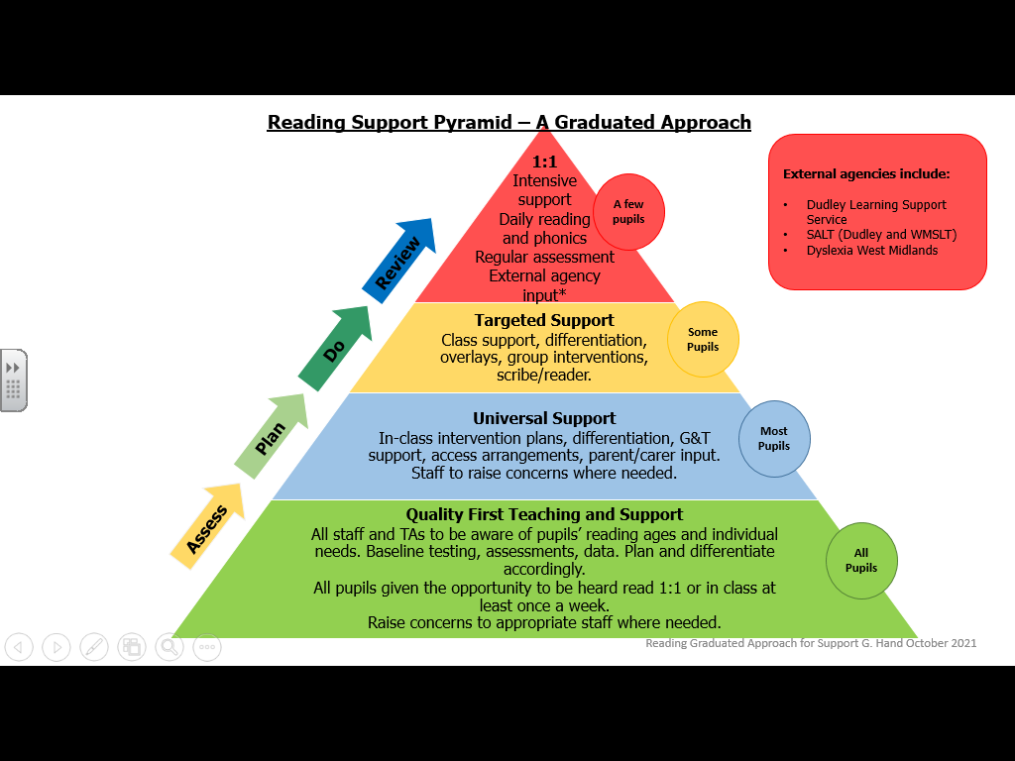

Key Pupils
- All staff are aware of key pupils who are significantly below ‘ARE’ and should differentiate in their lessons accordingly to ensure they can access the work across the curriculum.

Role of Parents/Carers
Our school actively encourages parents and carers to engage in their child’s education and reading. All KS3 and KS3 pupils now have a reading record (based on their reading age*) which is sent home with them for parents and carers to fill in. Pupils with phonics or reading interventions, will have a specific book sent home alongside this. KS4 pupils have the opportunity to take a reading record home, if they wish to do so. This can be filled in by themselves or by a parent/carer.
We see parents as important partners in the process of developing children’s reading skills. We therefore encourage parents to play their full part in their children’s education by:
This partnership is encouraged in the following ways:
- Parents/ carers to fill in reading records which can then be sent back to school
- Pupils are given opportunity to take books and texts home to share with parents and carers
- Giving parents termly outlines of the curriculum areas in English that each year group will be studying
- By encouraging parents to read with their child on a daily basis
- Encouraging their pupils to access online reading materials
*There are four different coloured reading records:
- Blue – (5-8 Years) New reader (reading and phonics log)
- Green – (9+) Developing reader (reading record and a guide for the reading helper)
- Orange (11+)- Advancing Reader (reading record and pages to support reading and writing)
- Purple (13+) - Confident Reader (reading record and pages to support reading and writing)

Leadership and Management
The SENCo, along with the English coordinator, are responsible for reviewing and improving the standards of teaching and learning of reading throughout the school by:
- Analysing data
- Pupil progress through lesson observations
- Book looks
- Pupil interviews
- Auditing and supporting professional development and training
- Purchasing and organising resources

