THE ROSEWOOD SCHOOL
Staff Responsible – Mr D. Kirk Policy Date – September 2021 Review Date – September 2022

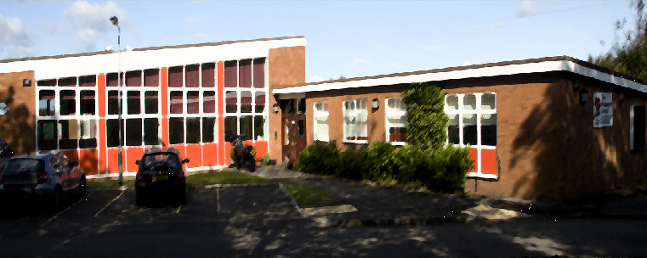
Mobile Device Policy 2021-2022
This policy is written with due regard to KCSiE 2021
For staff, visitors, volunteers and pupils
This policy provides clear guidance on the use of mobile devices and wearable technology in school by both staff, visitors, contractors and pupils.
Introduction
Rosewood School has a clear policy on allowing mobile technology use in school and this policy makes explicit reference to camera mobile phones, i-pads (or tablets) and wearable technology (e.g. Wearable technology).
Camera Mobile Phones, Tablets and Wearable Technology
Camera mobile phones and tablets and wearable technology are now part of our everyday lives and a built in digital camera enables users to take high resolution pictures. These can often be sent instantly to other mobile phone users or email addresses. They can also be posted on the internet or in chat rooms.
There is a potential for this technology to be misused in schools and can become an instrument of bullying or harassment directed against pupils or/and teachers.
Staff policy
Staff use of such personal electronic devices that use such technology during the working day should:
- be outside of their contracted hours
- be discreet and appropriate eg: not in the presence of pupils
- not be used in toilets
- ensure that Bluetooth or airdrop are hidden or disabled
Any personal electronic devices using this technology should be switched off/ set to silent and left in a safe place during lesson times. Wearable technology can be worn by staff but must be switched to airplane mode. The school cannot take responsibility for items that are lost, damaged or stolen. Staff are strongly advised to ensure they use protective passwords or pin numbers to avoid unauthorised calls or actions from their mobile device.

Staff should never contact pupils or parents from their personal mobile devices or give their mobile phone number to pupils or parents. If a member of staff needs to make telephone contact with a pupil, they should use the school telephone in the office.
Staff should never send to, or accept from, colleagues any texts or images that could be viewed as inappropriate, derogatory or abusive and would otherwise contravene our Behaviour or Safeguarding and Child Protection Policy.
Staff should never send to, or accept from pupils or parents (unless discussed with the Headteacher where staff are personal friends with other parents), any texts or images. With regard to personal mobile devices, a member of staff should never use these to photograph a pupil(s) or allow themselves to be photographed by pupils.
This guidance should be seen as a safeguard for members of staff, the school and the Local Authority. Staff should understand that failure to comply with the policy is likely to result in the enforcement of the Whistleblowing policy and associated safeguarding procedures, including the involvement of the LADO.
Parent, Visitors or Volunteers in School Policy
Parents, visitors or volunteers in school should only use their mobile device within the confines of the School Office or Staff Rooms or other areas as designated by a member of the Senior Leadership Team, dependent upon circumstance.
Adults either in school or accompanying children on school trips should not use their mobile devices to take pictures of pupils, unless it is at a public event such as Sports Day, Performances or the Summer or Christmas Fair and specific information for this will be given at each event.
If parents who accompany children on a school trip are asked by the teacher to take photos as a record of the educational visit, they will be issued with a school device. Parents accompanying children on school trips should not use their personal mobile devices to take pictures of children.

Contractors and Local Authority Employees Policy Contractors and local authority employee must leave their mobile devices in their pocket and ensure they are turned to silent or switched to airplane mode if a wearable device. Devices should only be used if required to take photographs of equipment or buildings or to speak to other colleagues and this must also be done in the presence of a member of staff (or in a private room if making a confidential call e.g. a social worker).

Pupil Policy
Whilst we fully acknowledge a parent’s right to allow their child to bring a mobile phone to school if they walk to and from school without adult supervision, Rosewood School discourages pupils bringing mobile phones to school due to the potential issues raised above. Pupils are not allowed to bring any other mobile devices or wearable technology into school.
When a child needs to bring a phone into school this will be turned off and handed to a tutor and be given back at the end of the day. Where a pupil is found by a member of staff to be using a mobile phone, the phone will be confiscated from the pupil, handed to a member of the office team who will record the name of the pupil and attach it to the phone. The mobile phone will be stored by the school office and the pupil may collect the phone at the end of the school day or given to a parent or carer. A letter will be sent home to parents informing them of inappropriate use of mobile technology in school. If this practice continues more than three times, then the school will confiscate the phone until an appropriate adult collects the phone from a senior member of staff.
Searches of mobile phones may be carried out in accordance with the DfE ‘Searching, Screening and Confiscation’ guidance. Pupils’ mobile devices may be searched by a member of the Senior Leadership Team with the consent of the parent/ carer and content may be deleted or requested to be deleted if it contravenes school policy.
If a pupil is found taking photographs or video footage with a mobile phone of either other pupils or teachers, this will be regarded as a serious offence and action will be taken according to our Behaviour Policy. If images of other pupils or teacher have been taken, the phone will not be returned to the pupil until the images have been removed by the pupil in the presence of a senior member of staff. (Please see more guidance on sexting in our Safeguarding and Child Protection Policy).
Should a pupil be found to be using their phone inappropriately, the school reserves the right to withdraw this privilege and they will no longer be able to bring a phone into school.
We ask that parents should talk to their children about the appropriate use of text messages as they can often be used to bully pupils.

Should parents need to contact pupils or vice versa during the school day, this should be done via the usual school procedure of contacting the school office via phone or email.

The policy supports the Health & Safety, Anti Bullying, Child Protection, Safeguarding and Internet/Digital Safeguarding policies. This policy will be monitored and reviewed as required but at least every two years.

