THE ROSEWOOD SCHOOL
Curriculum Policy 2021-2022
Staff Responsible Mr D Kirk Policy Date – September 2021 Review Date – September 2022

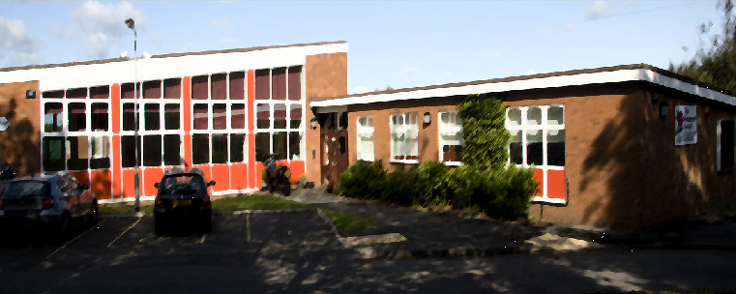
Contents
1. Curriculum aims
2. Legislation and guidance
3. Roles and responsibilities
4. Organisation and planning
5. Inclusion

6. Links with other policies

1. Curriculum aims
Teaching and learning is driven at Rosewood School through an ambitious curriculum. It has been designed with the aim of developing the knowledge, skills and abilities of pupils allowing increasing fluency and independent application of what they know and can do. The curriculum delivers a creative and practical approach to teaching and learning that challenges the more able further in their learning and appropriately supports children who find aspects of their learning more difficult. This enables success to be experienced by all. Our ultimate aim is to offer pupils the opportunity to achieve the outcomes and qualifications they need to progress into their chosen career pathways and to equip them for life after Rosewood.
Our curriculum offer is aligned with the National Curriculum as we strive to ensure pupils access a broad range of subjects throughout Key Stage 2, 3 and 4. The curriculum is planned and sequenced to provide pupils with cumulatively sufficient knowledge and skills to achieve their goals. In Key Stage 4 our curriculum tapers to allow pupils to focus their talents on subjects where they can attain recognised qualifications in the core subjects of English, Maths, Biology, Geography, ICT and two further subjects of their choice. Pupils leave Rosewood with between 8 and 10 GCSEs or equivalent. Rosewood does not offer a reduced curriculum for disadvantaged pupils or those with SEND. Instead we aim to maximise opportunities for all pupils to achieve through the setting of aspirational targets.

Further aims of our curriculum include
- Supporting pupils’ physical development and responsibility for their own health, and enabling them to develop independence.
- Promoting a positive attitude towards learning
- Equipping pupils with the knowledge and cultural capital they need to succeed in life
- Developing pupils’ independent learning skills and resilience, to equip them for further/higher education and employment

2. Legislation and guidance
This policy reflects the requirements of the National Curriculum programmes of study, which all maintained schools in England must teach.
It also reflects requirements for inclusion and equality as set out in the Special Educational Needs and Disability Code of Practice 2014 and Equality Act 2010, and refers to curriculum-related expectations of governing boards set out in the Department for Education’s Governance Handbook.

3. Roles and responsibilities
3.1 The governing board
The governing board will monitor the effectiveness of this policy and hold the Headteacher to account for its implementation.
The governing board will also ensure that:
- A robust framework is in place for setting curriculum priorities and aspirational targets
- Enough teaching time is provided for pupils to cover the National Curriculum and other statutory requirements
- Proper provision is made for pupils with different abilities and needs, including children with special educational needs (SEN)
- All courses provided for pupils that lead to qualifications, such as GCSEs and equivalents, are approved by the secretary of state
- The school implements the relevant statutory assessment arrangements
- It participates actively in decision-making about the breadth and balance of the curriculum
- It fulfils its role in processes to disapply pupils from all or part of the National Curriculum, where appropriate, and in any subsequent appeals
- Pupils from year 8 onwards are provided with independent, impartial careers guidance, and that this is appropriately resourced
3.2 Headteacher
The headteacher is responsible for ensuring that this policy is adhered to, and that:
- All required elements of the curriculum, and those subjects which the school chooses to offer, have aims and objectives which reflect the aims of the school and indicate how the needs of individual pupils will be met
- The amount of time provided for teaching the required elements of the curriculum is adequate and is reviewed by the governing board
- Where appropriate, the individual needs of some pupils are met by permanent or temporary disapplication from all or part of the National Curriculum
- They manage requests to withdraw children from curriculum subjects, where appropriate
- The school’s procedures for assessment meet all legal requirements
- The governing board is fully involved in decision-making processes that relate to the breadth and balance of the curriculum
- The governing board is advised on whole-school targets in order to make informed decisions
- Proper provision is in place for pupils with different abilities and needs, including children with SEN
3.3 Senior Management Team
Members of SMT will ensure that the school curriculum is implemented in accordance with this policy through our curriculum monitoring cycle.

4. Organisation and planning
Please find attached links to the curriculum statements with long term plans for each individual subject.

5. Inclusion
Teachers set high expectations for all pupils. They will use appropriate assessment to set ambitious targets and plan challenging work for all groups, including:
- More able pupils
- Pupils with low prior attainment
- Pupils from disadvantaged backgrounds
- Pupils with SEN
- Pupils with English as an additional language (EAL)
Teachers will plan lessons so that pupils with SEN and/or disabilities can study access the curriulum, wherever possible, and ensure that there are no barriers to every pupil achieving.
Teachers will also take account of the needs of pupils whose first language is not English. Lessons will be planned so that teaching opportunities help pupils to develop their English, and to support pupils to take part in all subjects.

6. Links with other policies
This policy links to the following policies and procedures:
- Assessment policy
- Non-examination assessment policy
- SEN policy and information report
- Equality information and objectives
- Individual subject policies/curriculum statements

